****NAMANGAN SHAHAR XALQ TA’LIMI BO’LIMIGA QARASHLI

NAMANGAN SHAHAR _____-SONLI UMUMIY

O’RTA TA’LIM MAKTABI INGLIZ TILI FANI

O’QITUVCHISI

***____________________________NING***

10 sinflar uchun Unit 4. Lesson 2 B  
***Priority organizer***

mavzusida 1 soatlik

**Dars ishlanmasi**



Namangan 2017

**Lesson 2.B. Priority organizer**

**The aim of the lesson**:

***Educational:*** - According to the lesson’s educational purpose improve pupils’ personal qualities like behavior, education etc. to improve pupils’ ideal-political knowledge, to form their developing skills and abilities.

***Developing:*** According to the lesson’s educational purpose develop pupils’ personal skills, English learning, motivational skills, develop pupils’ self-educational skills, analyzing and systematizing skills of knowledge, develop to report own ideas, communicative skills.

***С1, C2, C3, C4, C5, C6 Learning outcomes for competences in English:***

* By the end of the lesson pupils will be able to speak about intteligence, effort and success Pupils will be able to pronounce words
* By the end of the lesson, pupils will be able to understand to learn phrases for the theme and use them in small situations
* By the end pupils will able to to enable pupils to understand and perform commands, to enable pupils to learn Priority organizer’

***Linguistic competence:*** At the end of the lesson pupils will be able to improve Listening and speaking, reading and writing

***Sociolinguistic competence:*** *- raise awareness of your pupils organizing and scheduling events*

***Pragmatic competence:*** *- to enable pupils to find and use learned materials in different situations*

***Equipments***: “English” pupil’s book 10, handouts, DVD, technical aid, a blackboard and a piece of chalk.

***The method of the lesson:*** untraditional.

**Technological map of the lesson:**

**Motivation 3 minutes**

**To revise the previous lessons 8 minutes**

**Presentation- Explain new theme 14 minutes**

**Consolidation 10 minutes**

**Evaluation 5 minutes**

**Homework 5 minutes**

**Warm-up:**

* to introduce the vocabulary showing pictures
* to practice speaking

**The Procedure of the lesson:**

I Motivation: greeting, checking attendance, season, weather, checking the preparation for the lesson.

II. To revise the previous lesson.

To repeat the new words, exercises that have been done.

III. Presentation-Explain new theme.

B. Priority organizer

**Procedure of the lesson:**

***I. Organizing moment:*** Motivation,Greeting, checking attendance, season, weather, checking the preparation for the lesson.

***II. Asking homework:***

- Check for homework given on past lesson.

Ask pupils all new words learnt on previous lesson.

***III. Presentation*** -Explain new theme B. Priority organizer  
***Main part of the lesson:***

**Activity 1** Your pupils check their knowledge on grammar.

Check your grammar: Modal verbs 1. Complete the sentences with modal verbs.

***Answer key:***

|  |  |  |
| --- | --- | --- |
| **should/must** | **must/have to** | ***mustn’t/don’t have to*** |
| 1. must  2. must  3. should  4. must  5. should | 6. must  7. have to  8. must  9. must  10. have to | 11. mustn’t  12. mustn’  13. don’t have to  14. mustn’t  15. don’t have to |

**Use additional worksheets to enhance grammar skills. Distribute Handout 1**

**Activity 2 Fill in the gaps with the following words:**

*often, leave, busy, groceries, spends, takes, usually, around, late, time*



***Woman:*** So, what’s your usual day like? You always seem to

be so (1)________ .

***Man:*** Well, I (2) _________ get up around 5 a.m. and work

on the computer until 6 a.m.

***Woman:*** Why do you get up so early?

***Man:*** Well, I have to (3 )________ home at twenty to seven

(6.40 a.m.) so that I can catch a bus at 7 o’clock. It takes me

about twenty minutes to walk to the bus stop from my house.

***Woman:*** And what time do you get to work?

***Man:*** Uh, my bus (4 )______ about an hour to get there, but it stops right in front of my office.

***Woman:*** That’s nice. And what time do you get off work?

***Man:*** Uh, (5) ________ 5 o’clock. Then, we have dinner around 6.30. My wife and I read something or play with the kids until 8 p.m. or so.

***Woman:*** So, when do you work on your website? Once you said you had created it at home.

***Man:*** Well, my wife and I (6 )____ watch TV or talk until 10 o’clock. Then she often reads while I am working on my site, and I sometimes stay up until the (7 )_______ , but I try to finish everything by 1a.m. or 2 a.m.

***Woman:*** And then, you get up at 5 a.m.?

***Man:*** Well, yeah, but it’s important to live a balanced life. I enjoy what I do, but you have to set aside (8 )_______ for family and yourself.

***Woman:*** I agree.

***Man:*** But I think my wife has the toughest job. She (9) ________ her whole day taking care of our family: taking the kids to school, working in the garden, buying (10) ________ , taking the kids to piano lessons ...

Wow! That’s a full-time job, but she enjoys what she does.

***Woman:*** Well, it sounds you’re a busy but a lucky man.

***Man:*** I think so.

**Listen and check.**

***Answer key:*** 1. busy 2. usually 3. leave 4. takes 5. around

6. often 7. late 8. time 9. spends 10. groceries

**Activity 2 b. Choose the best answer:**

1. He gets to work at ...

a) 7 a.m. b) 8 a.m. c) 9 a.m.

2. At around 6.30 p.m. he and his family ...

a) read books together. b) play games, c) eat dinner.

3. He thinks it is important to...

a) enjoy the time. b) live a balanced life. c) keep secrets.

4. What is one thing the man does not say about his wife?

a) She has to take their children toschool.

b) She helps the kids with their homework.

c) She goes shopping for food

**Activity 3** Write numbers next to the pictures and put them in order.



**Activity 4** Check your predictions by reading the following text

**How to save time?!**

1. Take a shower or a bath at night, instead of in the morning. You can save time that way.

2. Start deciding the night before what to wear the next day. Leave everything you normally need to get ready in the morning out and ready. Also, decide how you will have your hair.

3. Prepare your breakfast in time.

4. If you take a lunch or snack with you to work or elsewhere - prepare and pack it the night before. You will make wiser (healthier, tastier, cheaper) choices preparing in advance.

5. Pack your work/school bag the night before. Have your bag ready with shopping lists, library books, borrowed videos, etc

6. Brush your teeth (every morning).

7. Do morning exercises before breakfast. It wakes up your mind for school/work and gets your blood pumping.

8. Get dressed and ready to go. Make your bed and you’re done in this room.

**Activity 5 Play video about tips how to manage time**Ask your pupils what are the tips for time management. And ask them which methods do they use and which methods they do not use.

***Optional Activity.* Stop the bus**

## Stop the Bus

This game brilliantly tests students on basic vocabulary with a hint of general knowledge keeping things interesting. By tapping into that competitive edge, this game makes students more cautious about spelling than they’d ever be in a simple mid-lesson Q&A between teacher and student.

**Rules:**

The students draw a table on a piece of paper with and fill it out with assigned topics, or you could hand out blank tables on worksheets. The topics give the game its general knowledge element. You could ask the students what topics they’d like to explore, or you could choose topics based on what you’ve been studying in class lately.

Either read these topics out loud or write them on the board to be copied down. Here’s an example of what this topics list might look like:

Name | Animal | Country | Food | Movie

For each round, the teacher writes one letter on the board. The first group, pair or individual to fill out the entire table on their sheet of paper with answers beginning with that letter shouts “stop the bus!” If the answers they’ve written down are correct, then they win the round.

As an example, with the topics above and the assigned letter as D, a student/group could write, “David | Dog | Denmark | Doughnut | Despicable Me.”

They’ll be awarded 10 points for every answer that no one else has written, 5 points if others have the same answer, no points if the answer is incorrect.

This can all be easily adapted. For example, if you’re practicing parts of speech, change the topics to verb, noun, adjective, etc. You can also choose whether to be very strict on spelling or not depending on the class level.

**Homework** Make your own calendar.

1. Fill in work hours.

2. Fill in family responsibility times.

3. Fill in class meeting times.

4. Designate remaining spaces as “free time”.

5. Fill in “free time” slots with specific tasks.

**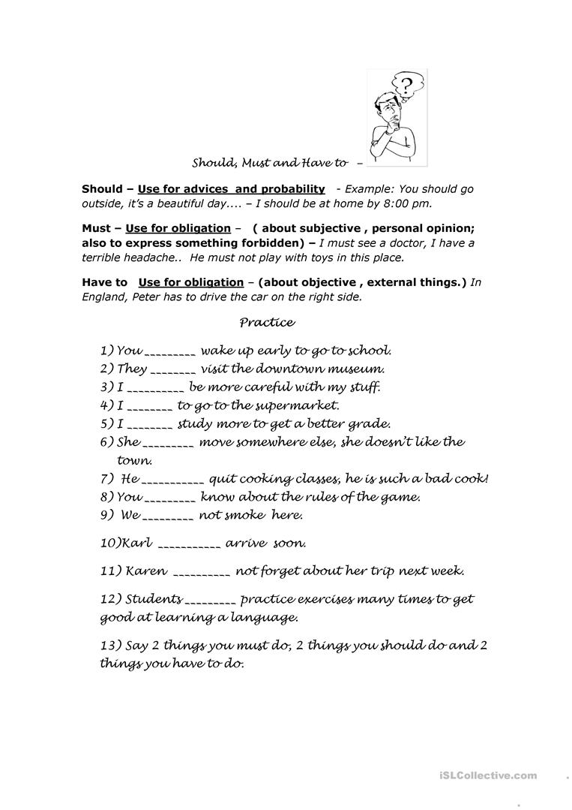***Head of teaching process_____________________ Signature _____*

*Handout 1*

O’zingiz tanlagan mavzuda dars ishlanmaga buyurtma berishingiz mumkin. Biz bilan bog’lanish +998911800985 qo’ng’iroq qiling,

+998911800985 telegram raqami, @hasanboy_uz Telegram adresi yoki [xasan_92@mail.ru](mailto:xasan_92@mail.ru) elektron pochtasiga habar yuboring

**Narxi 10 ming so’m**

To’lov payme yoki click orqali