NAMANGAN VILOYATI NORIN TUMANI XALQ TA’LIMI BO’LIMIGA QARASHLI
_____-SONLI O’RTA TA’LIM MAKTABI INGLIZ TILI FANI
O’QITUVCHISI
____________________________NING
3-sinflar uchun Unit 7. Lesson 2
They are big cats
mavzusida 1 soatlik

Dars ishlanmasi

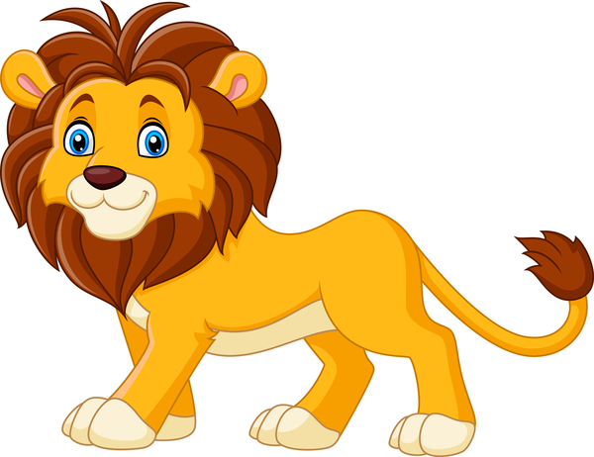

Namangan 2017 www.hasanboy.uz dan olindi
Date:________________Form:____________ ` Subject: English

Theme: They are big cats.
Aims:
Educational:
- to compare big animals using degrees of comparison
Developing:
- to enable pupils to listen, read and talk about big animals;
- to enable pupils to say characteristics of the animals.

Bringing up: -to bring up pupils to be interested in subjects
Socio-cultural: -to raise awareness of various big animals.
Type of the lesson: group work, pairwork
Method of the lesson: untraditional, mixed
Learning outcomes for English competence C1, C2, C3, C4:
By the end of the lesson pupils will be able to: - name big animals; -say characteristics of big animals; - describe big animals.
Visual aids: Textbooks, pictures, questionnaire, cards, maps, mp3 player, etc.
The procedure of the lesson:

№ | Part of the lesson | Tasks | Time
1 | Organizational  Moment | -to greet pupils. | 3 min
2 | Repeating last lesson | - to give pupils some questions about last lesson. | 5 min
3 | Explaining new theme | - to explain to pupils new vocabulary and theme | 20min
4 | Consolidating new theme. | - to consolidate new theme and new words of the theme. | 12 min
5 | Marking. | - To mark pupils | 2 min
6 | Homework. | - Giving homework. | 3 min

www.hasanboy.uz dan olindi
I Organizational moment:
Greeting with pupils using song
II Revising last lesson.
III Explaining new theme:
IV. Pre-Activity

Activity 1 Listen and repeat.
Objective: to warm up Ask the pupils to listen and sing the song “The elephant” together
with the DVD. DVD script:
DVD script:
The elephant goes
Like this, like that (On all fours, moving around slowly, like an elephant)
He’s terribly big, (Standing up, reach arms high)
And he’s terribly fat. (Stretch arms out to the sides, to show how fat elephant is)
He has no fingers, (Fisted hands, hiding fingers)
He has no toes, (Wiggle toes)
But goodness gracious,
What a nose! (Thumb to nose and wiggle fingers, as if extending trunk)

V. While Activity
Activity 2 Play “Listen and guess”.
Objective: to check the homework
Ask the pupils to work in pairs. Ask them to take their puzzles that they made at home, mingle and read them to each other and try to guess the animals. Ask them not to show the picture. They can show their picture only if their partner guesses the animal correctly.
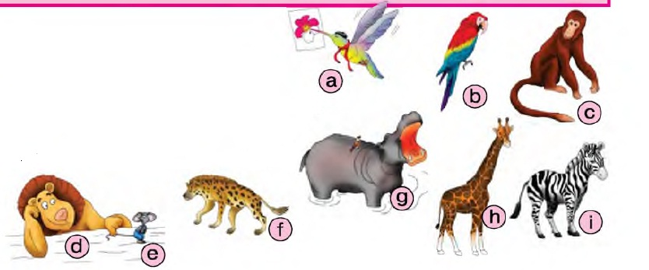

Activity 3a Look and put in order.
Objective: to reinforce the new vocabulary; to revise degrees of comparison.
Ask the pupils to look at the animals put in random order: lion, mouse, zebra, monkey, giraffe, hippo, hyena, parrot, humming bird. The pupils must put them in order from big to small.
Activity 3b Work in groups of 4. Play “Lions are bigger than hyenas”
Objective: to reinforce the new vocabulary, to revise degrees of comparison.
Put the cards with the animals on your table in random order: a lion, a tiger, a crocodile, a leopard, an elephant, a monkey, a giraffe, a hippo, a hyena, a parrot. Ask the pupils in turn take 2 cards and say the sentence e.g. “Elephants

Activity 4 Play “Let’s walk in the jungle”.
Objective: to reinforce the new vocabulary
Put the pictures of a parrot, a leopard and a crocodile somewhere on the walls in the classroom. Invite the pupils to go to the jungle. Ask them to follow you and be your echo. They must repeat all lines after you. First Group 1 repeats, then Group 2 repeats the same.

e.g. Teacher: Let’s walk in the jungle.
Group 1: Let’s walk in the jungle.
Group 2: Let’s walk in the jungle.
Let’s walk in the jungle.
We can’t see the birds.
Where’s the parrot?
Where’s the parrot?
Oh, look! It’s in the tree!
Let’s walk in the jungle.
We can’ t see the animals.
Where’s the leopard?
Where’s the leopard?
Oh, look! It’s in the tree!
Let’s walk in the jungle.
We can’ t see the animals.
Where’s the crocodile?
Where’s the crocodile?
Oh, no! It’s under me!! He-e-e-lp!

Activity 5 Look and complete the sentences.
Objective: to reinforce the new vocabulary
Ask the pupils to look at a mind map/in the circle - Leopards/ around: yellow, brown and black/dangerous/walk/run/climb trees/ big cats/meat/Africa.
Ask the pupils to complete the sentences using the information from the mind map.
Answer key:
Leopards are big cats.
They are yellow, brown and black.
They are dangerous.
They have spots.
They live in Africa.
They eat meat.
They can walk, run and climb trees.

Activity 6a Word search.
Distribute Worksheet 1 and ask your pupils to look the words and search them from the box. After completing ask several questions from worksheet to check their understanding.

Activity 6b Watch the video about big cats.
Before the playing video ask your pupils that what kind of big cats they know. Ask them a little about those animals. After, play the video and have them watch.

Activity 6b Label the cats
After watching the video distribute Worksheet 2 and ask your young learners to label the big cats. They should write the names of cats in spaces
www.hasanboy.uz dan olindi
VI. Post-activity
Optional Activity 6 Play “ Simon says” .
Say that you will play “Simon says” . It’s a usual “Simon says” game. The instructions can be e.g. jump like monkeys, walk like bears, fly like parrots etc.

VII. Homework
Draw the pupils’ attention to Homework 1. Explain that at first they must read the first text and compare it with the young giraffe beside. Then they must look at the old giraffe and complete the sentences about it. In Homework 2, the pupils choose any animal from the unit, draw and write about it. The pupils should do it on a separate sheet of paper as well. At the next lesson you will put the pictures with short stories on a class display.

VIII. Marking.
Worksheet 1
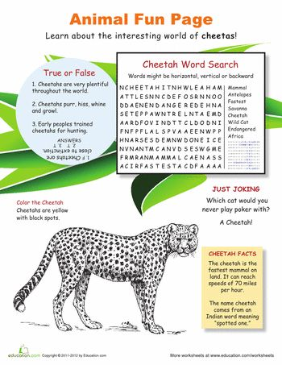

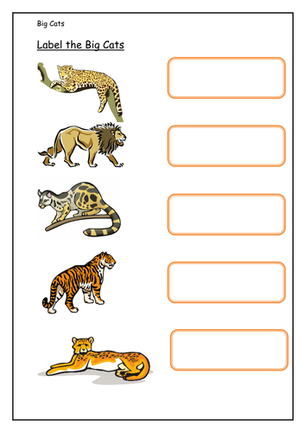
Worksheet 2

