NAMANGAN SNAMANGAN VILOYATI NORIN TUMANI XALQ TA’LIMI BO’LIMIGA QARASHLI

_____-SONLI DAVLAT IXTISOSLASHTIRILGAN

MAKTABI INGLIZ TILI FANI

O’QITUVCHISI

***____________________________NING***

8-sinflar uchun Unit 5. Lesson 1  
***Goodies and baddies***

mavzusida 1 soatlik

**Dars ishlanmasi**



Namangan 2017

**Date:________________Form:____________**

**Theme: Goodies and baddies**

**Aims:**

***Educational:*** To improve pupils’ listening, reading, oral speech and writing skills.

***Developing:*** To increase pupils’ knowledge and skills.

***Bringing up:*** To bring up pupils on the national ideology.

**Type of the lesson:** Mixed, group work, pairwork

**Method of the lesson:** untraditional, mixed

***Learning outcomes for English competence C1, C2, C3, C4:*** At the end of the lesson pupils will be able to learn how to describe and talk about the types of films and their characters

**Visual aids:** Textbooks, pictures, questionnaire, cards, maps, mp3 player, etc.

|  |  |
| --- | --- |
| **Active vocabulary** | |
| funny ['fʌnɪ] – quvnoq, kulgili  sad [sæd] – g’amgin, qayg’uli, zerikarli  happy ['hæpɪ] – baxtli, xursand, omadli | interesting ['ɪntrəstɪŋ] - qiziqarli  difficult [ 'dɪfɪk(ə)lt] -qiyin  historical [hɪs'tɔrɪk(ə)l] - tarixiy  old [əuld] – eski, qari |

**8. Stages:**

- Organizing moment: Greeting, Checking up pupils’ presence.

- Checking up pupils’ homework: Checking up pupils’ oral speech and pronunciation.

- New theme

- Consolidating.

***Pre-activity***

***Activity 1*** After greeting tell your class that what kind of important holiday is coming. Remember them about Constitution Day. Divide your class into 2 or 3 groups. Use sink or swim game to revise words from previous lesson. Include questions about Constitution Day. You can ask following questions:

* When was our constitution adopted?
* Who is the Head of our state?
* How many regions does Uzbekistan consist of ?
* Which countries does Uzbekistan border on?
* What is the legislative branch of Uzbekistan?
* What chambers does it consist of?
* How many members are there in the Legislative Chambers and the Senate?
* How are these members called in each chamber?
* How many members of the Senate can the President appoint?
* Who they maybe?

***While activity***

***Activity 2*** Before starting the theme, write “_” on the blackboard. Don’t tell your pupils about new theme. Write like this _ _ _ _ _ _ _ _ _ _ . And ask your class that here’s hidden the name of famous Hollywood actor Show picture of Johnny Depp.

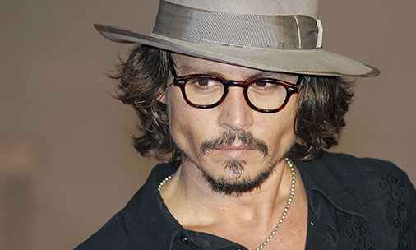 

They have to find his or her name by saying letters. Accept any letters from pupils. Pay attention to their pronunciation. If they say letter which puzzle has, write it to the blackboard. If there’s no letter draw horizontal line to the blackboard. If again incorrect answer, draw vertical line. Continue drawing until you receive correct answer as given below. In the end result will be like this:

The name of popular actor is Johnny Depp

You can show other popular stars picture

 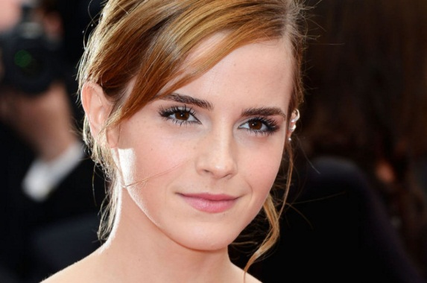 



1. Daniel Radcliffe 2. Emma Watson 3. Neslihan Atagul 4. Will Smith

**Questionnaire**

To find out what kind of movies your pupils like most, use sample questionnaire in below

***Activity 3* to practice the pupils to describe characters of films using these words and suggestions.**

Why these pupils like? Why don't you like the films? Do you agree?

'King Kong' is a science fiction thriller. I like 'King Kong' because I like science fiction films.

'Ajal so'qmog'i' (Deadly Path) is a detective film. I like it because it is very exciting.

'Braveheart' is a historical film about Scottish independence. I like the hero, 'Braveheart'. He is brave and good. I would like to be a hero like him.

'Tom and Jerry' is a cartoon. I don't like it because it is always the same. Tom and Jerry are goodies and they beat each other.

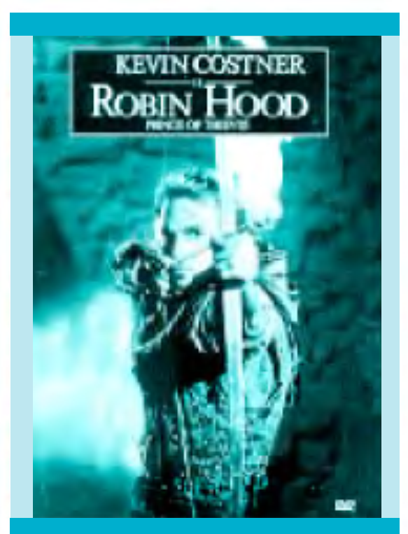

***Activity 4* to write about three films you have seen.**

I have seen Robin Hood film. It is about brave Robin and his friends who lives in the forest. They are legendary English men because they defend poor men and take care of them. They are always try to help people. They lived in the14th century. He took money from rich people and gave it to poor people

***Activity 5*** To practice pupil to write reviews of films which they have seen films

Ajal so'qmog'i' (Deadly Path) is one of the latest detective films in Uzbekistan. It is about a common problem - drugs and the terrible results for families. There are good and bad characters in the film. The famous filmstar Karim Mirhodiev is the baddie, Baslan. Jasur is a goodie. If you like films which have a serious message, this is a film for you.

'Robin Hood' is about a legendary Englishman. He lived in the 14th century. He took money from rich people and gave it to poor people. He is a goodie! The baddie is the Sheriff of Nottingham who treated poor people badly. Robin Hood became a national hero. In the film he is played by Kevin Costner. He is very handsome! If you like films which have a happy ending (and romance), this is a film for you.

*Optional Activity 6a* Work in pairs. Choose a film and write your own review.

**

*Optional* ***Activity 6b* using the review of *Skyfall* and to do the exercise to improve their writing skills.**

|  |  |  |  |
| --- | --- | --- | --- |
| Circle *True* or *False* for these sentences. | | | |
| 1. | | If you are writing a film review, you should write about a film that you have watched and can remember well. | *True* | | *False* | |
| 2. | | You should give your opinion of the film. | *True* | | *False* | |
| 3. | | You should mention basic information about the film such as the title, genre and actors' names. | *True* | | *False* | |
| 4. | | You should say what happens in the film's ending. | *True* | | *False* | |
| 5. | | You should talk about the acting, the music and the special effects and other individual aspects of the film. | *True* | | *False* | |
| 6. | | You should tell readers whether you think the film is worth seeing. | *True* | | *False* | |
| *Optional* ***Activity 6c***  **To circle the best phrase to complete these sentences.** | | | | | | | |
| 1. | *Skyfall* is a musical / an action film / a comedy . | | | | |
| 2. | The film was produced / came out on DVD / came out in cinemas in 2012. | | | | |
| 3. | The main character is Daniel Craig / James Bond / Raoul Silva. | | | | |
| 4. | James Bond / Javier Bardem / Raoul Silva is an ex-spy who wants revenge. | | | | |
| 5. | There are scenes in / characters from / songs from Istanbul, Shanghai, Macau, London and Scotland. | | | | |
| 6. | The writer especially liked / didn’t really like / had no opinion about Javier Bardem’s performance. | | | | |
| 7. | The writer recommends *Skyfall* only to / especially to / to everybody except people who like action films. | | | | |
| 8. | The writer thinks the film is interesting / funny / exciting until the very end. | | | | |

***Activity 7* Complete the gaps with a word from the box.**

|  |  |  |  |  |
| --- | --- | --- | --- | --- |
|  | | | | |
| |  | | --- | | soundtrack role plot set characters stars performance scene | | | | | |
|  | |  |  |  | |
|  | |  |  |  | |
| 1. | The film *Iron Man 3* _______________ Robert Downey Jr. as Iron Man. | | | |
| 2. | Voldemort in the Harry Potter films is played by English actor Ralph Fiennes. It was not an easy _______________ to play because he had to wear lots of make-up. | | | |
| 3. | Jennifer Lawrence became a huge star after her excellent _______________ in *The Hunger Games*. | | | |
| 4. | *The Hunger Games* _______________ contains some wonderful music and was produced by rock legend T-Bone Burnett. | | | |
| 5. | *Life is Beautiful* is _______________ in Italy in 1939. | | | |
| 6. | *Looper* has a very complicated _______________ involving time travel, and it is quite difficult to follow the story at some points. | | | |
| 7. | Scriptwriters sometimes create _______________ who are based on people they have met. | | | |
| 8. | In the opening _______________ of *Skyfall*, Bond accidentally gets shot by his partner. | | | |

***Post activity***

***Activity 8*** Play the video about genres. Ask your pupils what kind of genres are popular and what genres they like.

**Homework:**

**Marking**

**Questionnaire Name_____________________**

**1. How old are you?** I’m ______ years old.

**2. What is your gender?** Female Male

**3. What is your favourite movie genre?**

Comedy Horror Thriller Romance

If other, please specify _____________________

**4. What is your favourite movie?**

__________________________________________________________________

**5. How often do you watch movies?**

Not very often often A lot

**6. How do you find out about new movies?**

____________________________________________________________________________________________________________________________________

**7. How do you watch newly release movies?**

Cinema Online

DVD rental TV

If other, please specify _____________________

**8. Who is your favourite actor/actress? _______________________________**

**9. Would you be more likely to watch a movie if that actor was featuring in it?**

Yes

No

**10. Would you consider watching this movie after seeing the poster?**

Yes No

Maybe

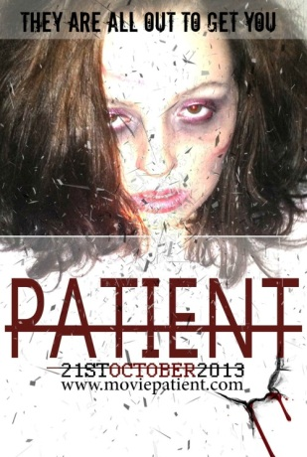and why?_______________________________________________________

O’zingiz tanlagan mavzuda dars ishlanmaga buyurtma berishingiz mumkin. Biz bilan bog’lanish +998911800985 qo’ng’iroq qiling,

+998911800985 telegram raqami, @hasanboy_uz Telegram adresi yoki [xasan_92@mail.ru](mailto:xasan_92@mail.ru) elektron pochtasiga habar yuboring

**Narxi 10 ming so’m**

To’lov payme yoki click orqali