O’zbekiston Respublikasi Xalq ta’limi vazirligi
Uchtepa tuman Xalq ta’limi bo’limi

297 sonli umumiy o’rta ta’lim maktabi

Ingliz tili fanidan

“English in our school life”
Nomli

OCHIQ ESHIKLAR KUNI

taddbiri

Madhiya yangraydi…
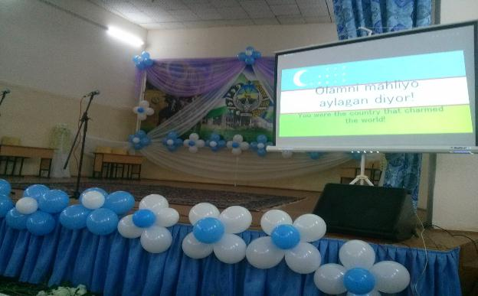
Qo’ng’iroq chalinadi. Bolalar shovqini…
“Assalom” qo’shig’i yangraydi. 2 sinf o’quvchilari shu qo’shiq jo’rligida o’tirganlarga salom berishadi.
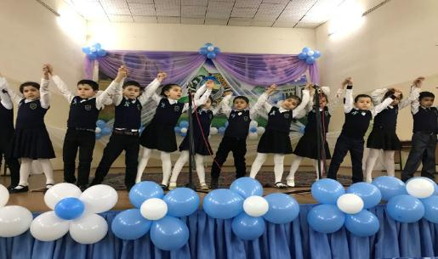
Boshlovchi barcha matnlarni sahna ortidan o’qiydi…
Boshlovchi: Hammaga salom! Mening ismim… Yo’q, yaxshisi, o’zimni tanishtirmayman. Bo’lmasa, menda Hoshimjonnning sehrli qalpoqchasi borligini bilib qolasiz. Keling, sizni maktabimiz va undagi mehribon ustozlar bilan tanishtiray…
Hello everybody! I’m… No, no. I don’t introduce myself, because if I say my name, you may know that I have a magic cap. Let’s introduce about our school and our kind teachers.
Bu bizning maktabimiz – 297 maktab… Maktabimizda bilimli o’qituvchilar juda ko’p. Mana bu bizning direktorimiz – Zulhumor Ibragimovna! Biz uchun onamizdek qayg’uradilar. Darslarmiz, baholarimiz haqida bizdan-da ko’p o’ylaydilar. Mana, hozir ham 10 sinf o’quvchilari bilan tarbiyaviy suhbat o’tkazyaptilar.
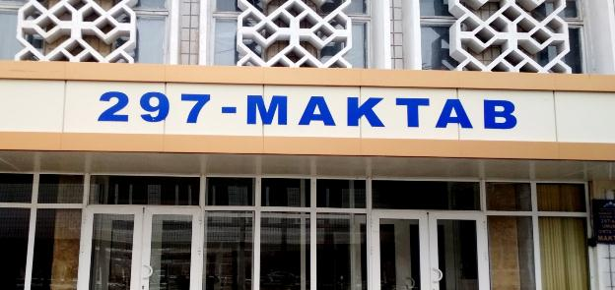
This is our school – number of 297 (two hundred ninety seven). There are so many smart teachers in our school. That is our director – Zulhumor Ibragimovna. She worries about us as our mother. She thinks more about our lessons and marks than we think. Look, as usual she is talking with pupils of form 10. 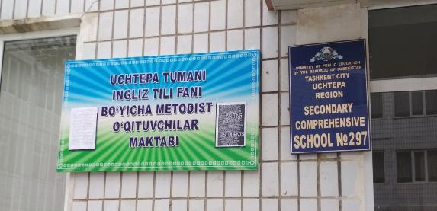
Ie, gap bilan bo’lib dars boshlanganini ham bilmay qolibmanu… Bugun maktabimizda ochiq eshiklar kuni! Bu kunda barcha darslar ingliz tilida olib boriladi. Bugun sinfxonalar eshigi barcha uchun ochiq. Keling, biz ham sinfxonalarni aylanib, darslarni kuzatamiz.
Today is open doors day in our school. All subjects interact to English in this day. Let’sobserve some lessons together! Look, the pupils are greeting to their teachers..
Good morning to all teachers!

(“Good morning” qo’shig’i)
Good morning, good morning,
The best to you this morning
How are you, how are you
I hope, you’re feeling fine,
And happy all the time!
Boshlovchi: Ie kichkintoy o’quvchilar ABCni kuylashyaptimi? Xaa, ularda hozir ingliz tili darsi ekan…
Those little pupils are singing ABC. Ooh, they have English lesson now.
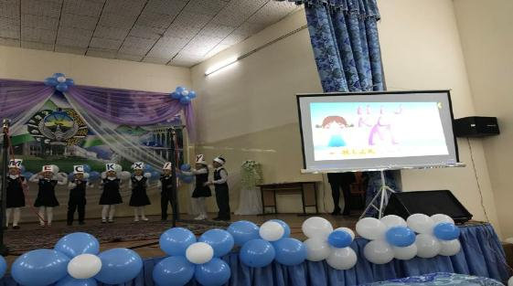
(2-sinf ABC qo’shig’i)
A, B, C, D, E, F, G,
H, I, J, K, L, M, N, O, P
Q, R, S, T, U, V
W, X, Y and Z
Now I never will forget
How to say my alphabet!
Boshlovchi: Keling, boshlang’ich sinfdagi darslarni kuzatishda davom etamiz. 3-sinfdagi “Tabiatshunoslik” darsiga kiraqolaylik…
Let’s continue to observe the lessons at beginner classes. Now come in “Nature” lesson of the form 3.
3 sinfda “Tabiatshunoslik” darsi. Ikki o’quvchining suhbati.
1-o’quvchi: Soliha, do you know, spring is coming. I lik spring very much. Because the sun shines and it often rains in it. Ooh, Soliha, look it is raining now. Let’s take an umbrella!
2-o’quvchi: Menga ham bahor fasi juda yoqadi. Ayniqsa, men yomg’irni juda-juda yaxshi ko’raman. Voy, ana yomg’ir yog’yapti. Yur, soyabonlarimiz ostiga berkinib olamiz!
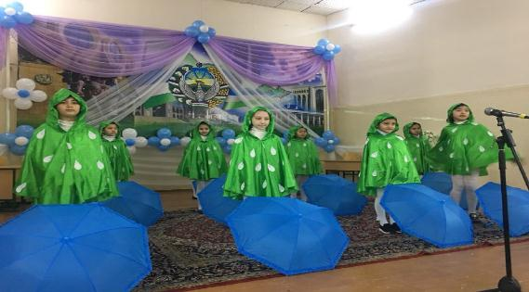
(3 sinf) “Rain, rain” qo’shig’i
Rain, rain, go away,
Come again another day,
Little Johnny wats to play…
Boshlovchi: Qoyil! Bu bolalarni ko’rib, xuddi yomg’ir ostida qolganday his qildim o’zimni…
Great! I feel myself as a person who stayed under the rain after I saw these children…
Ie kimdir soat minutlari haqida gaplashyaptimi? Xaa, 4 sinf o’quvchilari matematika darsida “Soat” mavzusini o’tishyapti.
So, we’ll observe mathematics lesson in form 4. The pupils of this grade are learning about Clock with English song.
4 sinf o’quvchilari soat haqida ingliz tilida suhbatlashishadi.
- What’s the time?
- It is ten o’clock.
- What’s the time?
- It is six o’clock
- What’s the time?
- It’ is twelve o’clock.
Shundan so’ng o’quvchilar “What’s the time” qo’shig’ini kuylashadi.
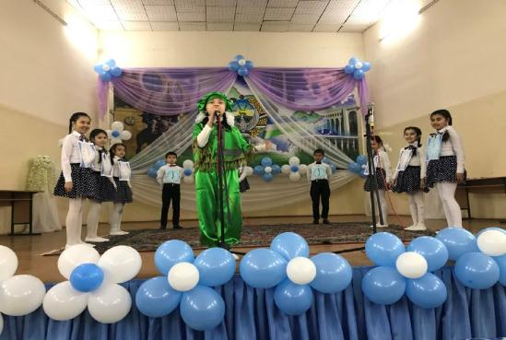
(4-sinf) “What’s the time” qo’shig’i
What’s the time, what’s the time, what’s the time?
It’s one o’clock, it’s two o’clock, it’s three o’clock,
It’s four o’clock, it’s five o’clock, it’s six o’clock.
It’s seven o’clock, it’s eight o’clock, it’s nine o’clock,
It’s ten o’clock, it’s eleven o’clock, it’s twelve o’clock…
What’s the time, what’s the time, what’s the time?
Boshlovchi: Ana, soatni ham bilib oldik… Endi yuqori sinflar tomonga yo’l olsak! Ie, xov anavi ayolni ko’ryapsizmi? Ular o’quv ishlari bo’yicha direktor o’rinbosari – Gulnora opamiz. Dars paytida koridorda yursangiz, ulardan baloga qolasiz! Mana, manavi o’quvchilar ham tozaa gapni eshitishyapti… “Boshqa qilmaymiz, ustooz…” deyishyapti shekilli.
Mana bu xonada 7 sinf o’quvchilari geografiya darsida o’tirishibdi. Ular O’zbekiston Respublikasining geogafik tuzilishi haqida gaplashishyapti
It is geography lesson in this room with form 7. They are talking about the geographical structure of Uzbekistan.
(7-sinfda geografiya darsi)
O’qituvchi kiradi va uch nafar o’quvchi bilan suhbat o’tkazadi
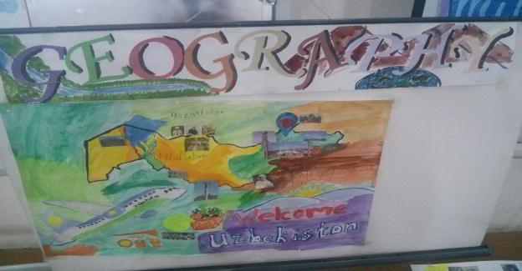
O’qituvchi: Bolalar, esingizda bo’lsa, bugun darsimizni ingliz tilida olib borishga kelishgan edik. Let’s begin our geography lesson. Are you ready for the lesson?
O’quvchilar: Yes, we are!
O’qituvchi: If you’re ready, let’s talk about the geographical structure of our country. Who wants to be first? Please, Sevara!
1-o’quvchi: Uzbekistan Republic is one of the five Republics of Central Asia. Uzbekistan is situated between the Amu Darya and Syr Darya the greatest Asian rivers. It is the region of flat-lands mountains and deserts.
O’qituvchi: Very good, Shahzoda! Who can tell us about the territories and borders of Ubekistan?
2-o’quvchi: The territory of the Republic covers 447,4 thousands square kilometres and is larger than Great Britain or Italy. Uzbekistan borders on Kazakhstan, Kirgizia, Tajikistan and Turkmenia. In South Uzbekistan borders Afghanistan.
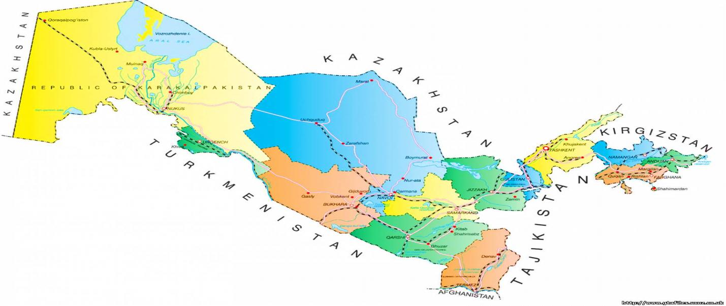

O’qituvchi: Thank you! Then let’s speak about regions, please Muslima!
3-o’quvchi: About regions
O’qituvchi: Very good! Our country is the best in Central Asia. It is well its nationality, its hospitality, its friendly towards to others and kindness.
Hamma birgalikda: Uzbekistan – the great past, the great future! We love our motherland and protect from enemies!
(Qo’ng’iroq chalinadi)
Boshlovchi: Va nihoyat, katta tanaffus! Eng ajoyib daqiqalar boshlanadi hozir. Koridordagi shovqin-u to’polonlar, oshxonadagi uzuuun navbat kutib turgan bolalar-u, somsa qolmaganidan xafa bo’lib chiqib ketayotgan o’quvchilar… Baribir bularning gashti boshqacha…
Ie, qarang, jismoniy tarbiya darsidan qaytayotgan o’quvchilar qo’shiq kuylab kelishyaptimi? Yana ingliz tilidaa…
Look, those pupils are singing the song in English!
(“If you’re happy”)
Boshlovchi: Tanaffus tamom! Hamma darsga! Bu so’zlarni katta tanafusdan keyin ko’p eshitasiz! Ayniqsa oshxona oldidagi faeda... To’g’ri-da, tanaffus tugagandan so’ng darsga kirish kerak-ku. Mana, 5-sinf o’quvchilari allaqachon adabiyot darsini boshlab yuborishibdi. Ular Alisher Navoiy ijodini o’rganishyapti…
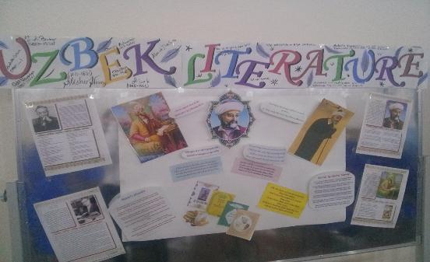
The pupils of form 5 have already start literature lesson. They are learning about Alisher Navoi.
(5-sinfda adabiyot darsi.)
5 sinf o’quvchilari Alisher Navoiy g’azallarini ham o’zbek, ham ingliz tillarida aytishadi.

1-o’quvchi: For me to die in bitter torment
It’s easy bit without you,
I better die, hey soul, to stay
I can’t admit without you.
A dead man cannot breath at all,
However when you look at me
The lamentation and weeping
Do not quit without you.
2-o’quvchi: Jahonki muqaddas, neni ko’ribdi,
Bariga onasan, ey, qodir hayot!
Asrlar qa’ridan boqib turibdi
Nurli bu yuzlarga nuroniy bu zot!
3-o’quvchi: Navoi would be immortal if you
Do not break the tryst.
But he can live not a moment
Life will split without you.
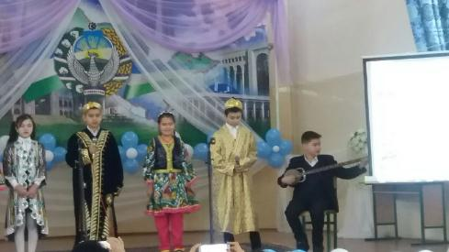
G’azaldan so’ng “Mustahzod” qo’shig’i va 5 sinf qizlari tomonidan raqs ijro etiladi.
Navoiy va bulbul suhbatining ingliz tilida sahnalashtirilgan sahna ko’rinishi namoyish etiladi.
Navoiy g’azal o’qiyotganida atrofida uchib yurgan bulbul unga aytadi:
Bulbul: Oh, you have a very pleasant voice. What’s your name?
Navoiy: I’m Alisher.
Bulbul: I know. But you need some nickname and this nickname should be dependent on your name. I want to call you Navoi. Because your “navo” attracts everybody’s attention.
Hikoyachi: Shundan beri shoir Alisher o’ziga Navoiy taxallusini olgan ekan…
Boshlovchi: Qoyil! Maktabdoshlarimning ochilmagan qirralarini kashf etib bormoqdaman. Ajoyib iqtidorli bolalar bizning maktabda juda ko’p. Masalan, 5 sinf o’quvchilarini olaylik. Ular “Bolajon” telekanalidagi “Happy alphabet” ko’rsatuvida muvaffaqiyatli ishtirok etib kelishmoqda.
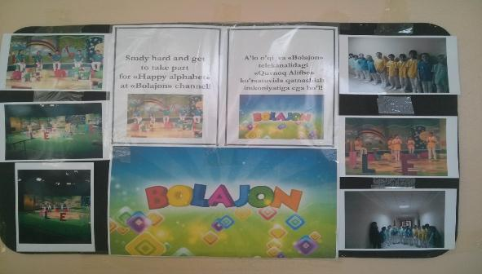
Wonderful! There are so many I pupils in our school! Such as, the pupils of form 5 have been taking part at “Happy alphabet” on “Bolajon” channel.
Ie, anavi sinfxonada 9 sinf o’quvchilari „Harakatlar strategiyasi” haqida gaplashishyapti. Bu xonada huquq darsi bo’layotgan ekan. Now let’s come in the grade of 9 to observe law lesson. They are talking about “Development strategy”.
(9-sinf o’quvchilari “Harakatlar strategiyasi”ni o’zbek-ingliz tillarida gapirishadi)

1-o’quvchi: The first aspect of Development Strategy of Uzbekistan. Priority areas of improving the system of state and public construction. The symbol of this aspect is blue. This colour was the State of Amir Temur too.
2-o’quvchi: The second aspect is law. Priority areas for ensuring the rule of law and further reforming the judicial system. The symbol of this aspect is purple.
3-o’quvchi:The third aspect of Development Srategy is economics. Priority aeas of economic development and liberalization.
4-o’quvchi: The fourth aspect of Development Strategy of Uzbekista is development community. Priority areas of development of the social sphere. The symbol of this aspct is red. Red is a colour of life and more wins.
5-o’quvchi: Priority areas in the field of security, inter-ethnic harmony and religious tolerance, as well as the implementation of balanced, mutually beneficial and constructive foreign policy. The colour of this aspect is white. White is a symbol of peace and pure life. 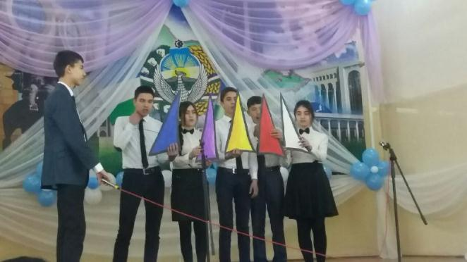
Boshlovchi: Mmm… Dimog’imga mazali pishiriqning yoqimli hidi urildi. Xa, mehnat darsida 6-sinf qizlari shirinlik tayyorlashayotgan ekan. Yaxshisi, shu darsni ham kuzatamiz. Balki, bizga ham bir bo’lakdan pishiriq tegib qolar...
Lets, observe handicrafts lesson with the grade of 6. The girls are making a sweet in this room. Come in this lesson, maybe they will give us a piece of cake…

6 sinf o’quvchilari quymoq tayyorlashning bosqichlarini ingliz tilida aytishadi:
- Let’s make a pancake!
- Let’s begin!
- Take a litre of milk, some oil, some salt and some sugar
- Put them in a big pot
- Mix them well
- Pour the mixture into a frying pan
- When the pancakes are dark yellow, they are ready
- Eat them with some butter!
- 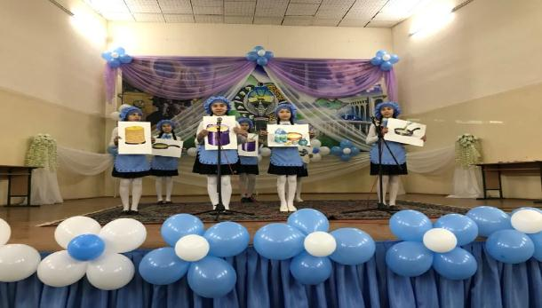
Shundan so’ng ular qo’llariga pishiriq solingan idishchani ushlab, “Pat a cake” qo’shig’ini aytishadi:
(6 sinf) “Pat a cake qo’shigi
Pat a cake, pat a cake,
Baker’s man
Bake me a cake
As fast, as you can.
Pat it down, break it down,
Mark it with B
Put in the oven for
Baby and me.
Qo’shiq tugagach, qizlar qo’llaridagi shirinliklarni zalda o’tirgan mehmonlarga ulashadilar.
Boshlovchi: Mana, bugungi ochiq eshiklar kunidagi darslarimiz ham tamom bo’ldi. Endi barcha istirokchilarni sahnamizga taklif etamiz.
Our Open Day event is over. Now we invite all participates to the hall!
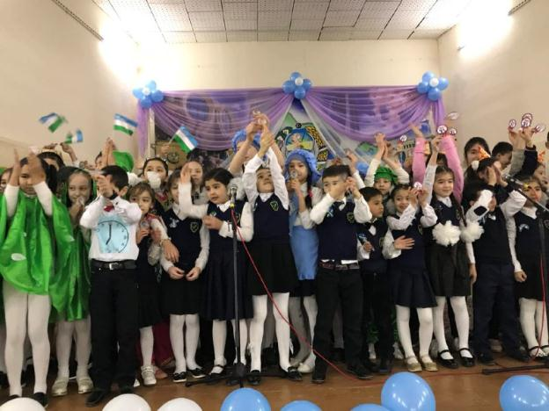
(Tadbirda ishtirok etgan o’quvchilar sho’x qo’shiq jarangida sahnaga siqishadi. Barcha ishtirokchilarga “Eng faol o’quvchi” nomli esdalik nishonlari taqdim etiladi)
Thank you for your attention!

