www.hasanboy.uz dan olindi

Qoraqalpog’iston Respublikasi Amudaryo tumani 5- sonli umumta’lim maktabining Ingliz tili fani o’qituchisi Ermetova Ibodatning Ingliz tili fan oyligiga bag’ishlangan “ We love English” nomli bellashuv ssenariysi

The scenario for the month of foreign languages. This party is for the 3rd grades. This scenario is mainly completion that compete two groups. The group each group consist of 6 pupils.
The aim of the party are: to revise all materials by doing tasks.
to consolidate listening, reading and writing skills.
The equipment of the party: pictures, multimedia, cards, markers.

Teacher: Good morning dear guests and children. Today we can performance the competition of 3rd grades. You know May is month of foreign languages. They prepared this competition in order to show how much they are good at English. We all wish all of participants good luck. Let me introduce the parts of competition.
- Greetings. In this part each of groups should introduce themselves.
They should say: what is …. Name? where does ……live? How old is…? What is ….hobby? ( 4 min for each group)

- Listening task: this task is group work. The teacher gives a sheet of paper for each groups. In this task both groups listen to the audio task and should fill the gaps to their sheet of papers( 3 min for each group)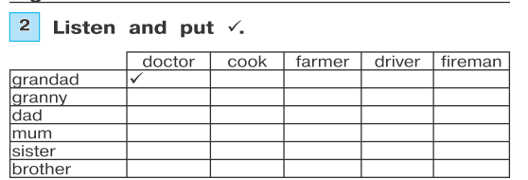
- Reading task: this task is group work. The groups should find which picture is and tick it. ( 5 min for each group)
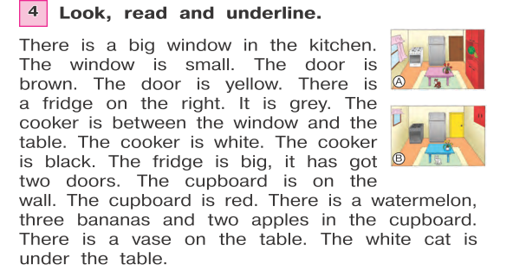
- Grammar and lexical task: Pupils should complete the sentences using the degrees of adjectives. 5 min for each group
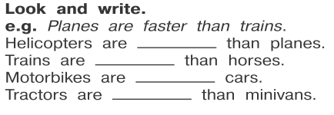
- It is musical part and writing task. It named as “ Running dictation”. The teacher sticks words for two groups on the wall or blackboard. There should be one participate that writes words which pupils spell to the writer one by one until the music stops. ( 5 min for each group)
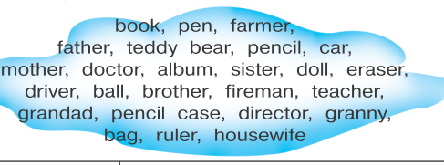

- Picture dictation. There will be a picture of the family and pupils should stick the names of members that given in the text which are spelt by teacher. ( 10 min)
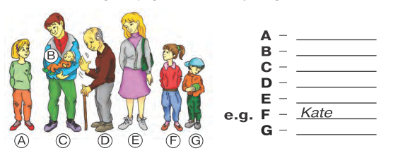
Teacher: Well as you see our pupils are so active and well learned. They could show how they love English. We wish all of them good luck and great future. Thank them for participating. Our party is over goodbye.
At the end of the party the teacher value the winners.

www.hasanboy.uz dan olindi

