Хоразм вилояти Богот туманидаги
8 – сон умумий урта таълим мактабининг
Инглиз тили фани укитувчиси
Ниёзметова Зебо Зафарбековнаниг
6 – синфлар учун
инглиз тили фанидан RASMLI тестлари

1. The ……………knows about the books and help children to find books.

a) doctor b) cook c) librarian d) teacher 2. Choose the correct answer?
- A doctor works in the office and helps to sick people.
- A gardener works in the garden and he likes flowers.
- A cook work in the school and helps to learn
- A secretary work in the garden and works with papers.
3. 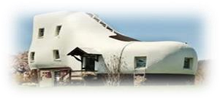 Find the name of this unusual house, which you can see.
  - The Austo house c)Stone house
  - The Shoe house d)The Flying house 4. what food should we eat to have good hair?
a) Eggs and fish, b) milk c)cheese d) potetoes
- I am white or brown, I have a hat. I grow on the ground.
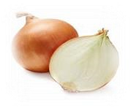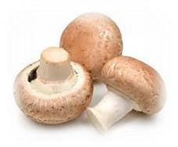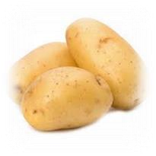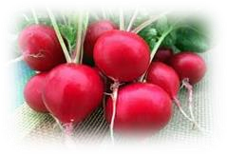

  - Onion b) mushroom c) potato d) radish
- I would like a …………. Chocolate.
  - Bar of b) packet of c) botlle of d) jar of
- Where did Pizza come from……….?
a) Africa b) Mexico c) Italy d) Aisa

- Answer the question. How much are potetoes?
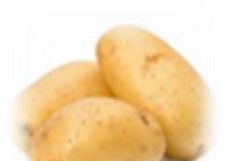
  - two thousand and fifty.

250

  - Two hundered and fifty.
  - Twenty five and thousand.
  - Two hundered and twenty five.
- Find the extra word.
a) Traingle b) circle c) square d) raisins
- Choose the correct answer. Where did chocolate come from?
  - China b) Mexico c) Aisa d) Italy
- Where is the Eiffel Tower
  - London b) England c) France d) Great Britain 12. What do English people do when they meet?
  - Shake hands
  - Nod and shake heads
  - Say hello and their noses
13. 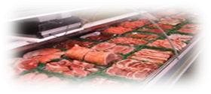 What can we buy in the meat section?
a) Sausage b) cake c) yougrt d)poteto 14. Complete these words.
A bottle of___________
A jar of _____________
A cup of __________
- Jam,water, tea.
- chocolate, salad, meat
- Jam,water, meat
- chocolate, salad , tea.
15. 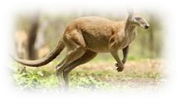 Where do Kangaroos live?
a) Australia b) New Zealand c) Africa d) America

1 | 2 | 3 | 4 | 5 | 6 | 7 | 8 | 9 | 10 | 11 | 12 | 13 | 14 | 15
c | b | b | a | b | a | c | b | d | b | c | b | a | a | a

