  
 **\_\_\_\_\_\_\_\_\_\_\_\_\_\_ VILOYATI \_\_\_\_\_\_\_\_\_ TUMANI XALQ TA’LIMI BO’LIMIGA QARASHLI**

**\_\_\_-SONLI O’RTA TA”LIM MAKTABI**

**INGLIZ TILI FANI O’QITUVCHISI**

***\_\_\_\_\_\_\_\_\_\_\_\_\_\_\_\_\_\_\_\_\_\_\_\_\_\_\_\_\_\_\_NING***

5-sinflar uchun Unit 10. Lesson 2  
***What can animals do?***

mavzusida 1 soatlik

**Dars ishlanmasi**

\_\_\_\_\_\_\_\_\_\_\_\_\_\_\_ -2018

**Date\_\_\_\_\_ Form\_\_\_\_\_ Subject: English**

**Theme: What can animals do?**

**Aims:**

***Educational****:* - to learn the story “Mowgli”; - to learn about the animals in the jungle.

***Developing:*** - to enable pupils to talk about animals’ habitat and things they can do; - to develop reading for specific and detailed information.

***Up bringing****:* - to enrich pupils’ knowledge of our tradition and nation

***Learning outcomes for English competence C1, C2, C3, C4, C5, C6:*** At the end of the lesson pupils will be able to talk about the animals in the jungle; - the things the animals

can do.

***Type of the lesson:*** Mixed, group work, pair-work, individual work

***Method of the lesson:*** nontraditional, mixed

***Equipment of the lesson:*** Textbook “New Fly High 5”, pictures, internet, computers, projector

**TECHNOLOGICAL MAP OF THE LESSON:**

|  |  |  |  |
| --- | --- | --- | --- |
| **№** | **Part of the lesson** | **Tasks** | **Time** |
| 1 | Organizational  Moment | -to greet pupils.  - to check up the register | 5 min |
| 2 | Repeating last lesson | - to give pupils some questions about last lesson. – to ask words from previous lesson | 5 min |
| 3 | Explaining new theme | - to explain to pupils new vocabulary and theme | 20 min |
| 4 | Consolidating new theme. | - to consolidate new theme and new words of the theme. | 10 min |
| 5 | Marking. | - To mark pupils | 5 min |
| 6 | Homework. | - Giving homework. |

**Procedure of the lesson:**

***I. Organizing moment:*** Motivation,Greeting, checking attendance, season, weather, checking the preparation for the lesson.

***II. Asking homework:***

- Check for homework given on past lesson.

- Ask pupils all new words learnt on previous lesson.

***III. Pre-activity:***

***Activity 1* Listen and repeat.** *10 min*

**Objectives:** to warm up by singing the song; to check homework

*STEP 1:* Play the DVD. Ask the pupils to listen to the song and repeat it. Look at Unit 10 Lesson 1 Activity 1 for the DVD script.

*STEP 2:* Checking homework. Ask the pupils to read their sentences to each other, listen to the sentences and guess the animal.

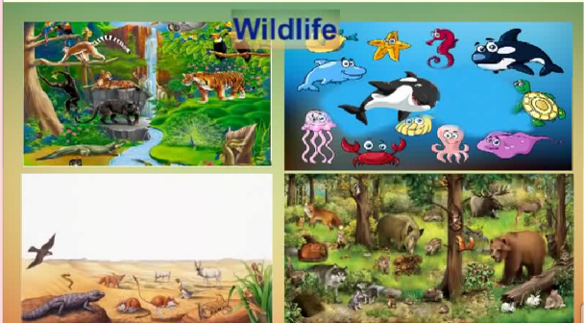

***IV. Main part***

***Activity 2* Find the new animals. Listen and repeat.** *5 min*

**Objective:** to introduce the new vocabulary

*STEP 1:* Ask the pupils to look at the picture and name the animals they know. Ask “Which animals live in the jungle?”

*STEP 2:* Introduce the new words. Ask them to repeat all the words after you or the DVD.

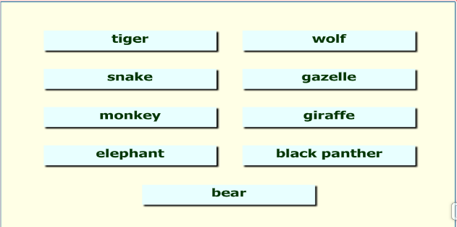

***Activity 3a* Read and answer the questions.** *5 min*

**Objective:** to read for specific information

Ask the pupils to read the text or listen to the text in the DVD and answer the questions. Explain that they must use the Past Simple Tense in their answers.

See Pupil’s book for the DVD script.

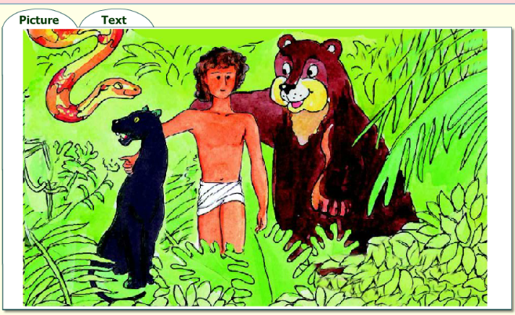

People live in cities and villages. Look at the boy in the picture. He lived in the jungle. His name was Mowgli. He did not live with his parents. In the jungle his father was a wolf. His mother Ruksha was a wolf too. Little wolves were his brothers. He liked playing with them. Mowgli had a lot of friends: the bear Balu, the black panther Bagira and the big snake Kaa. They were kind to Mowgli and looked after him. The tiger Sher Khan wanted to eat him up. There were a lot of monkeys in the jungle. They wanted to take Mowgli because he looked like a monkey. Mowgli was happy in the jungle because it was his home.

***Activity 3b* Read and match the animals and their names.** *5 min*

**Objective:** to read for detailed information

The pupils match the names and the animals. You can also use the DVD for this purpose.

1 Ruksha

2 Bagira

3 Balu

4 Kaa

5 Sher Khan

a black panther

b tiger

c big snake

d bear

e wolf

***Answer key:*** 1e; 2a; 3d; 4c; 5b

***Activity 3c* Write T for True or F for False.** *7 min*

**Objective:** reading for detailed information

Ask the pupils to read the sentences and write T for true or F for false. Give them time to find the answers in the text.

***Answer key:*** 1) T; 2) F; 3) F; 4) F; 5) T; 6) F; 7) T; 8) T

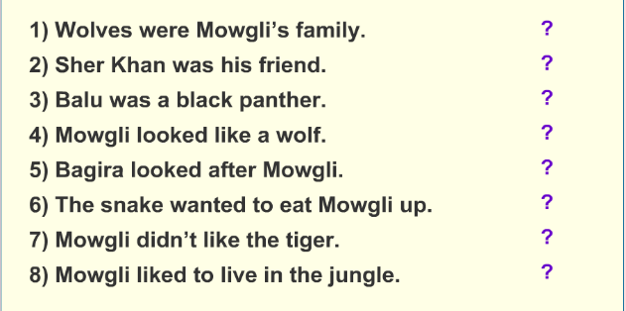

***Activity 4a* Write what animals in the jungle can do.** *10 min*

**Objective:** to reinforce the use of “can + verb” for ability through writing

*STEP 1:* Ask the pupils to look at the pictures and the verbs under them.

Ask the meaning of the verbs. Then have the pupils repeat the words after you.

*STEP 2:* Ask the pupils to make sentences about what the animals in the

jungle can do using the verbs they have just revised.

**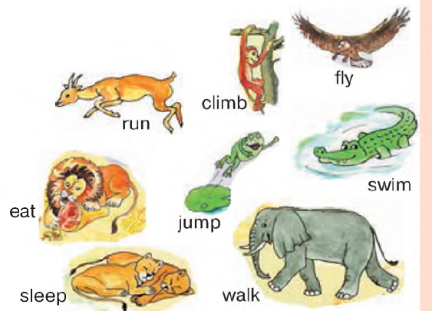**

***Activity 4****000803_1058_6616_v__v_thm****b.* Look and write can or can’t.**

They ­­­\_\_\_\_run, but they \_\_\_ swim. They \_\_\_\_\_smell, but they \_\_\_ fly.

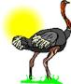

010409_0713_0089_v__v_thm

They \_\_\_\_\_ Fly, but they \_\_\_\_ run. They \_\_\_\_\_read, but they \_\_\_\_ hear.

***Activity 4c* Who am I? Read, match the pairs and write down their names.**

a) I can smell we can touch. I can’t fly but we can jump. I like grass.

b) I am small bird. I am black and white. I can ’t fly, but I can swim. I like fish.

c) I am long and green. I can’t speak, but I can smell. I live in jungle.

d) I am very big and grey. I can run, but I can’t climb up a tree. I have got long trunk.

 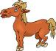  

\_\_\_\_\_\_\_\_\_\_\_ \_\_\_\_\_\_\_\_\_\_\_ \_\_\_\_\_\_\_\_\_\_\_ \_\_\_\_\_\_\_\_\_\_\_\_\_

***V. Post-activity***

***Activity 5* “Animal Riddles”**

**Objective:** to reinforce vocabulary of animals, to teach think logically

**Answer Key & Instructions Team Game**

* The first page of “Animal riddles” can be used as an individual worksheet (reading and writing focus). Help with spelling or vocabulary if necessary.
* The second page can be used as a competitive team game (reading, speaking, pronunciation and listening focus).
  + Divide the class into 2 or 3 teams.
  + One team reads out the clues slowly and clearly - one by one - on one of their cards. Don’
  + Other teams listen and try to guess the animal. ONLY ONE GUESS IS ALLOWED, so teams have to work together and not guess too quickly.
  + If all the clues are exhausted, teams could show the pictures or give extra clues.
  + Teams score one point per correct answer.
* These rules can be adapted or used creatively. Enjoy.
* After the game, students can choose an animal and write their own clue cards.

bat

panda

goat

ant

sea star or starfish

goldfish

hamster

deer

chicken or hen

bee

guinea pig

camel

donkey

zebra

octopus

wolf

sheep

bear

eel

crab

fox

***VI. Evaluation.*** Giving marks

***VII. Homework***

Ask the pupils to look at the homework. Check that everybody understands what to do with the 2 tasks. If necessary, explain how to do the homework.

***Possible answers:***

**Task 1:** 1) *climb* / *fly*. 2) *swim* / *jump*. 3) *jump* / *climb*. 4) *run* / *fly*.

**Task 2:** The mountains in *Uzbekistan* are beautiful. There are a lot of *flowers* there. In the mountains there are a lot of small animals, snakes, birds and *beautiful* butterflies too. It is very cold in the mountains in *winter*. Not many big animals live there. It is a *habitat* for wild goats and sheep, hyenas and bears.

******

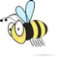ant**Animal Riddles**

Can you find out what I am?

b

I can fly.

I am not a bird.

I sleep during the day.

I am black.

I live in China.

I am a kind of bear.

I am black and white.

I eat bamboo.

I have four legs.

I live on the farm.

I bleat.

I give milk.

I am a small animal.

I like sugar.

I have six legs.

I am red or black.

I live in the sea.

I am not a fish.

You can’t eat me.

I usually have 5 arms.

I’m a kind of pet.

I am orange.

I live in a bowl.

I can swim.

I am a small pet.

I don’t have a tail.

I keep food in my cheeks.

I am active at night.

I live in the forest.

I eat grass.

People hunt me.

I have antlers.

I have two legs.

I lay eggs.

I live on the farm.

I cluck.

I can fly.

I have six legs.

I am yellow and black.

I collect honey.

I am a small pet.

Some people eat me.

I am not a pig.

I’m not from Guinea.

You can ride me.

I don’t drink often.

I live in the desert.

I have a hump.

I live on the farm.

I look like a horse,

but have longer ears.

I bray or hee-how.

I eat grass.

I live in Africa.

I am black and white.

I look like a horse.

I can swim.

I have eight arms.

I have a soft body.

I can change colour.

I’m a wild animal.

I howl.

I hunt in packs.

I look like a dog.

You can eat me.

I am white.

I bleat or baa.

I give wool.

I live in the forest.

I can be dangerous.

I am black or brown.

I like fruit and honey.

I have no legs.

I can swim very well.

I look like a snake.

I am slippery.

I can swim.

I have a hard shell.

I move sideways.

I have eight legs.

I have four legs.

I live in the field.

I am cunning or sly.

I love chickens.



ch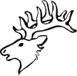ca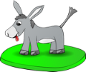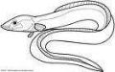gp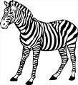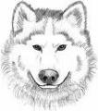

Don’t show this to other teams!

Give an extra clue if needed.

Don’t show this to other teams!

Give an extra clue if needed.

Don’t show this to other teams!

Give an extra clue if needed.

I can fly.

I am not a bird.

I sleep during the day.

I am black. BAT

I live in China.

I am a kind of bear.

I am black and white.

I eat bamboo. PANDA

I have four legs.

I live on the farm.

I bleat.

I give milk. GOAT

I am a small animal.

I like sugar.

I have six legs.

I am red or black. ANT

I live in the sea.

I am not a fish.

You can’t eat me.

I usually have 5 arms.

SEA STAR or STARFISH

I’m a kind of pet.

I am orange.

I live in a bowl.

I can swim. GOLDFISH

I am small.

I am a pet.

I keep food in my cheeks.

I am active at night. HAMSTER

I live in the forest.

I eat grass.

People hunt me.

I have antlers. DEER

I have two legs.

I lay eggs.

I live on the farm.

I cluck. CHICKEN or HEN

I can fly.

I have six legs.

I am yellow and black.

I collect honey. BEE

I am a small pet.

Some people eat me.

I am not a pig.

I’m not from Guinea.

GUINEA PIG

You can ride me.

I don’t drink often.

I live in the desert.

I have a hump. CAMEL

I live on the farm.

I look like a horse,

but have longer ears.

I bray or hee-how. DONKEY

I eat grass.

I live in Africa.

I am black and white.

I look like a horse. ZEBRA

I can swim.

I have eight arms.

I have a soft body.

I can change colour. OCTOPUS

I’m a wild animal.

I howl.

I hunt in packs.

I look like a dog. WOLF

I live on the farm.

You can eat me.

I am white.

I give wool. SHEEP

I live in the forest.

I can be dangerous.

I am black or brown.

I like fruit and honey. BEAR

I have no legs.

I can swim very well.

I look like a snake.

I am slippery. EEL

I can swim.

I have a hard shell.

I move sideways.

I have eight legs. CRAB

I have four legs.

I live in the field.

I am cunning or sly.

I love chickens. FOX

Team 2

Team 3

Team 1



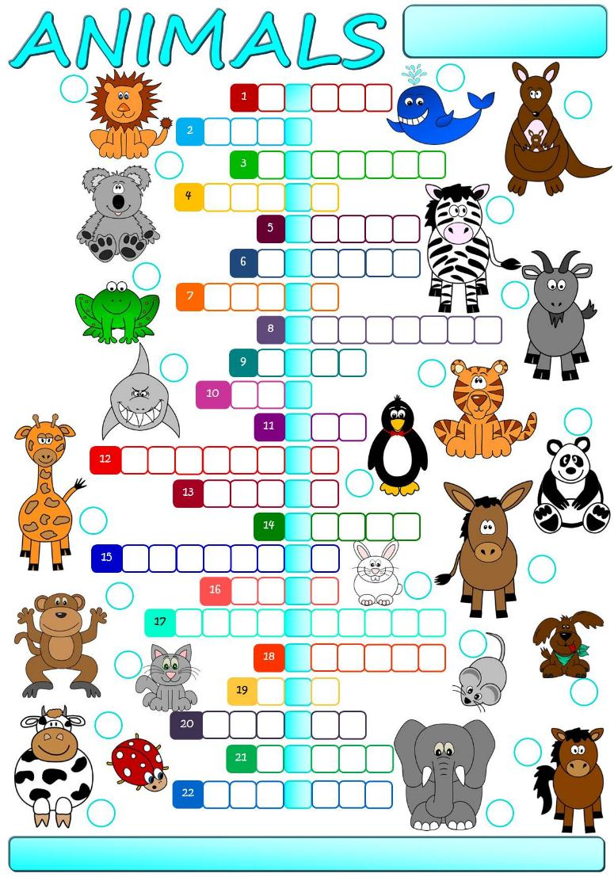

**Match the words to the correct pictures and complete the crossword. Then find a secret message.**

**cat**

**cow**

**dog**

**donkey**

**elephant**

**frog**

**giant panda**

**giraffe**

**goat**

**horse**

**kangaroo**

**koala**

**ladybird**

**lion**

**monkey**

**mouse**

**penguin**

**rabbit**

**shark**

**tiger**

**whale**

**zebra**

The secret message is \_\_\_\_\_\_\_\_\_ \_\_\_\_\_\_\_\_\_\_ \_\_\_\_\_\_\_\_\_ \_\_\_\_\_\_\_\_\_ \_\_\_\_\_\_\_\_ \_\_\_\_\_\_\_\_ **summer.**

Siz istagan mavzuda sifatli qilib dars ishlanma tayyorlab beramiz.

**Narxi: 10 ming so’m**

To’lov klik yoki payme orqali

Buyurtma berish uchun bog’laning:

Telefon: +998911800985  
**Telegram:** +998911800985 yoki @hasanboy\_uz  
**E-mail:** [xasan\_92@mail.ru](mailto:xasan_92@mail.ru)