O‘ZBEKISTON RESPUBLIKASI XALQ TA’LIMI VAZIRLIGI
ANDIJON VILOYATI XALQ TA’LIMI BOSHQARMASI
ANDIJON TUMANI XALQ TA’LIMI BO‘LIMI TASARRUFIDAGI
___-UMUMTA’LIM MAKTABI INGLIZ TILI FANI O‘QITUVCHISI _____________________________NING
5-SINFDA UNIT 5 I like English. Do you?
LESSON 2 WHAT TIME IS IT? MAVZUSIDAGI ILG’OR
PEDOGOGIK TEXNOLOGIYA USULLARI SINGDIRILGAN
DARS ISHLANMASI
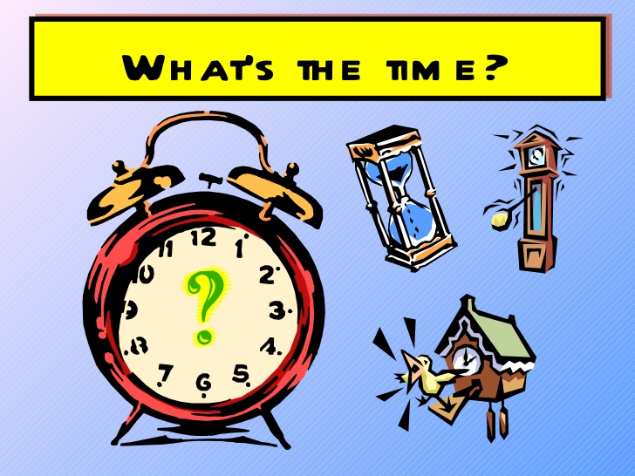
ANDIJON-2017

DATE: ______________
Grade: 5^{A}
Theme:Unit 5. I like English. Do you? Lesson 2. What time is it?
Aims:
Educational:
- to learn to ask and tell the time
- to learn to use prepositions with times
Developing:
- to enable pupils to ask and tell the time.
Socio cultural:
- to raise awareness to ask and answer the time.
Learning outcome: At the end of the lesson pupils will be able to ask the time, tell the time and use time prepositions.
Vocabulary and structure: past, to, quarter, half, when, minute, break, o’clock
Required equipment: pupils book, multimedia, projector, handouts, tables, pictures of clocks, flashcards, color pencils
The beginning of the lesson:
1. Organizational moment.  Time: 3 minutes  Greeting | The teacher greets with pupils:  - Good morning, teacher!  - Good morning, dear pupils!  - Thank you. You may sit down. I am very glad to see you again.
Making English  atmosphere (speaking) | Teacher: We have 2 duties. Who are on duty today?  (two duties stand up)  Teacher: Please, give me a report!  (Duties give daily report. It is based on the date, weather, news, absence)
Procedure of the lesson:
Warming up
Objective:
- Warming up
Time: 14 minutes
Interaction: pair work
Procedure:
Sing the song.
STEP 1: Play the DVD. Ask the pupils to listen to the song and sing it. STEP 2: Ask the pupils to swap their exercise books in pairs. Ask them to check each other’s homework. Then you can check the homework involving the whole class.
In order to recall the previous lesson let’s play snowball. I will throw snowball to one of you and the pupil who will have received should say a school subject with “I like…” Who wants to be the first?
Explanation the theme (10 minutes): I’m going to explain the new theme. Listen carefully! In order to tell the time we need to know several words and word expressions. In English when we say about time we use “It is” at the beginning of the sentence. For example:
It is 9 o’clock (9:00) It’s half past 10 (10:30) It’s quarter to 12(11:45)
Differently in English, first of all we should say the minute of the time and then the o’clock. For instance:
It’s 20 minutes past 11(11:20) It’s 25 (minutes) past 3 (3:25)
Consolidation part:
Objective: to raise awareness to tell the time
Time: 3 minutes
- It’s your turn pupils. Please, show me your understandings. (Pupils come to the blackboard and show their clocks and say the times)
Activity 4b. Look and write.
Objective: to practise telling the time
Time: 5 minutes
The pupils look at the clocks and write the time. After having finished listening they can check their work themselves. Then PP repeat the times after the DVD.

Extra activity. Work in groups. Match the clocks with the written times.
Objectives: to develop pupil’s speaking skills
Time: 5 minutes
Materials: handouts , pieces of paper
Interaction: group work
Procedure:
- Read, match the clocks with the written times
- Explain the pupils when they finish they should stick it on the board.
At the end of the lesson
Assessment:
Time: 3 minutes
Assess the pupils according to their participation. Explain the given marks.
Homework:
Time: 2 minute
Ask pupils to open their class books to Page 58. Explain what to do in Activity 1a,1b,1c. They should deal with the clocks and times.
Thank you for your participation, especially pupils who were active during the lesson.
The lesson is over. See you next lesson. Good bye!
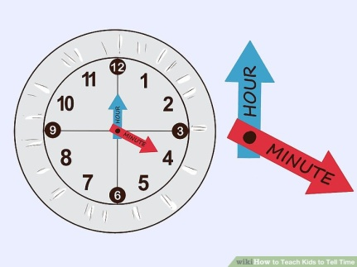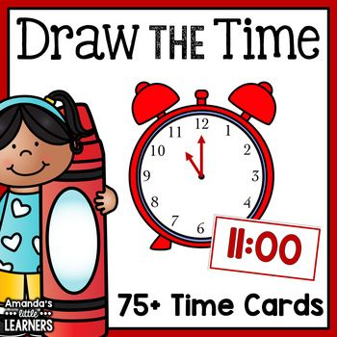

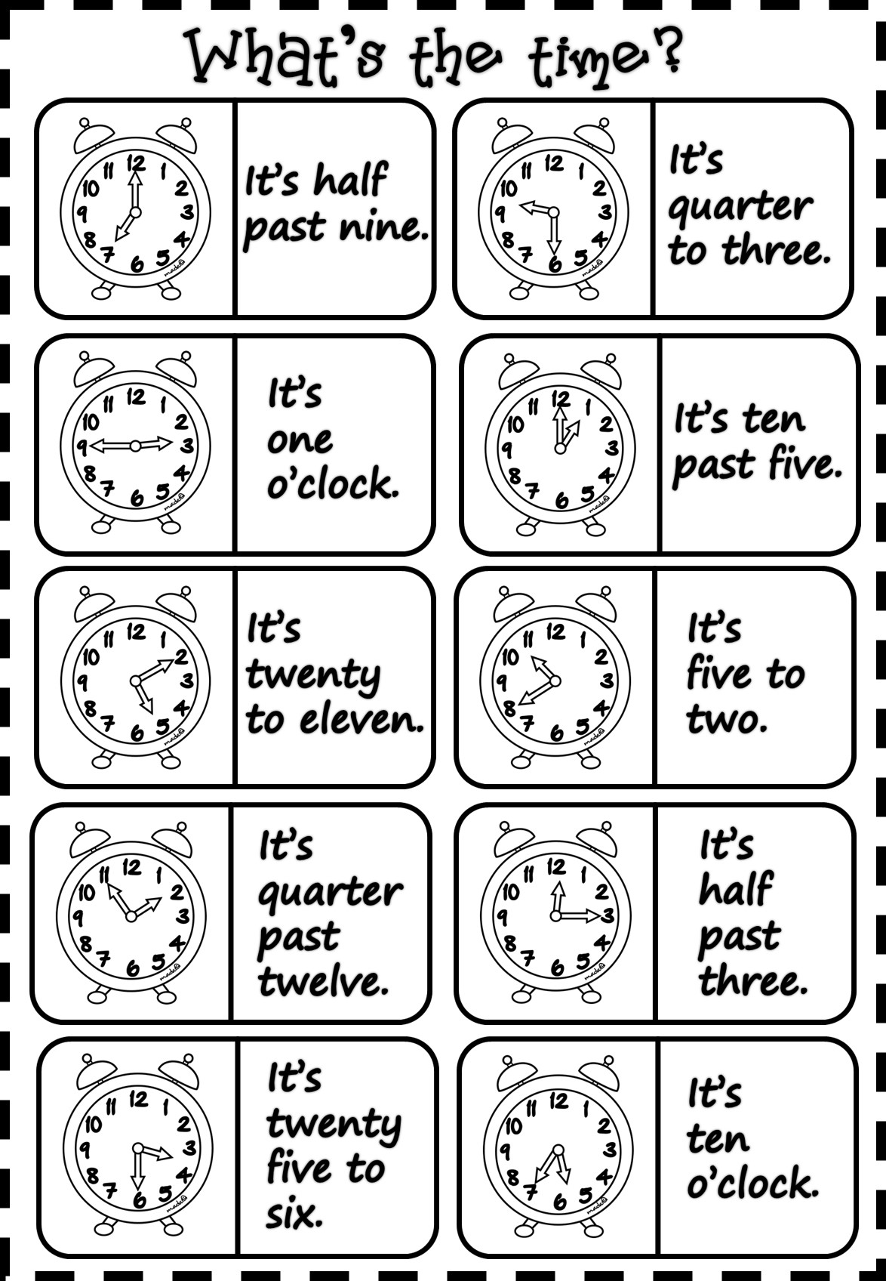

O’zingiz tanlagan mavzuda dars ishlanmaga buyurtma berishingiz mumkin. Biz bilan bog’lanish +998911800985 qo’ng’iroq qiling,
+998911800985 telegram raqami, @hasanboy_uz Telegram adresi yoki xasan_92@mail.ru elektron pochtasiga habar yuboring
Narxi 10 ming so’m
To’lov payme yoki click orqali

