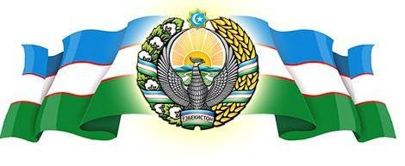  
***__________* VILOYAT *________* TUMANI XALQ TA’LIMI BO’LIMIGA QARASHLI**

**___-SONLI O’RTA TA”LIM MAKTABI**

**INGLIZ TILI FANI O’QITUVCHISI**

***_______________________________NING***

7-sinflar uchun Unit 8. Lesson 5  
*What do the flags say?*

mavzusida 1 soatlik

**Dars ishlanmasi**

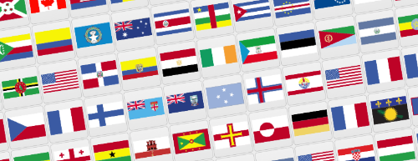

_______________-2018

**Date_____ Form_____ Subject: English**

**Theme: What do the flags say**

**Aims:**

***Educational****:* - to teach pupils to express their ideas and talk about the flags of the UK, the USA and Uzbekistan

- to introduce and practise the words for country, nationality and language

***Developing:*** - to practise listening and reading for specific information

- to revise ‘I think that’ for speculating about things

***Socio-cultural:*** - to recognize flags of countries and their meaning

***Up bringing****:* - to enrich pupils’ knowledge of our tradition and nation

***Learning outcomes for English competence C1, C2, C3, C4, C5, C6:*** At the end of the lesson pupils will be able to talk about the flags of the UK, the USA and Uzbekistan

***Type of the lesson:*** Mixed, group work, pairwork

***Method of the lesson:*** nontraditional, mixed

***Equipment of the lesson:*** Textbook “Fly High 7”, pictures of flags, internet, computers, projector

**THE PROCEDURE OF THE LESSON:**

|  |  |  |  |
| --- | --- | --- | --- |
| № | Part of the lesson | Tasks | Time |
| 1 | Organizational  Moment | -to greet pupils.  - to check up the register | 5 min |
| 2 | Repeating last lesson | - to give pupils some questions about last lesson. | 5 min |
| 3 | Explaining new theme | - to explain to pupils new vocabulary and theme | 20 min |
| 4 | Consolidating new theme. | - to consolidate new theme and new words of the theme. | 10 min |
| 5 | Marking. | - To mark pupils | 5 min |
| 6 | Homework. | - Giving homework. |

**Procedure of the lesson:**

***I. Organizing moment:*** Motivation,Greeting, checking attendance, season, weather, checking the preparation for the lesson.

***II. Asking homework:***

- Check for homework given on past lesson.

Ask pupils all new words learnt on previous lesson.

***III. Pre-activity:***

***Activity 1a Look at the flags and say the country.***

Objective: to revise the material of the 6th form

PP match the countries and the flags in their Ex.Bks.

  

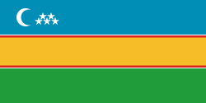 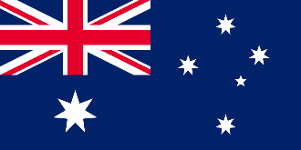

***III. Main part***

***Activity 1b Listen and repeat.***

**Objective:** to introduce and practise the words for country, nationality and language

PP listen, read and repeat after the tape. Then they can do point and say.

See Classbook for Tapescript

Culture Note: Draw PP attention to the fact that Canada is a bi-lingual country. You can also tell them that many people in the USA speak Spanish, and that some people in the UK speak Welsh (in Wales) and Gaelic (in Scotland).

***Suggestion:*** You could do Grammar Exercise 2 here. It gives further practice in countries and languages.

|  |  |  |
| --- | --- | --- |
| Country | Nationality | Language |
| New Zealand  Great Britain  The USA  Uzbekistan  Australia  Canada | a New Zealander  English  American  Uzbek  Australian  Canadian | English  English  American English  Uzbek  English  English, French |

***Activity 1c Work in pairs. Look at the picture in 1a. Introduce people and countries.***

**Objective:** to practise introducing people in an international setting

This is a Chain drill done in pairs.

e.g. Hello. I’m Carol. I’m from Canada. I’m Canadian. I speak English and French.

This is Tom...

***Activity 2a Listen, read and say which flags are not described.***

**Objective:** to practise listening and reading for specific information

PP listen and read the text and then answer the question.

See Classbook for Tapescript

**Key:** the New Zealand, Australian, Canadian, Karakalpak flags are not described.



***Activity 2b Work in pairs. Ask and answer.***

Objective: to practise talking about flags

PP work in pairs and take turns to ask and answer the questions. If your PP

find it difficult to make questions, you can give them some questions:

1) What do the crosses on the British flag represent?

2) What do the stripes on the Uzbek flag represent?

3) What do the stripes on the American flag represent?

4) What do the colours on the Uzbek flag represent?

5) What do the colours on the American flag represent?

6) What do the stars on the Uzbek flag represent?

***Activity 2c Work in pairs. Guess what the symbols on the other flags represent.***

Objective: to revise ‘I think that’ to speculate about the meaning of unknown

Flags PP continue to work in their pairs and try to interpret some other flags.

***IV. Post-activity***

***Activity 3*** ***Play “Board game”***

Take dice and ask your pupils to roll it and answer the question

***V. Evaluation.*** Giving marks

***VI. Homework.*** Ask your pupils to colour the flags at home

Ireland[United States](http://www.theodora.com/flags/united_states_flag.html)[](javascript:edit(95629))

**A person from France**

Start

**A person from Japan**

**Capital of France**

**A person from Greece**

[NetherlandsSpain](http://www.theodora.com/flags)[](javascript:edit(95629))

**A person from Holland**

**A person from Germany**

**A person from Italy**

**Capital of England**

[Germany](http://www.geographic.org/flags/germany_flags.html)[United Kingdom](http://www.theodora.com/flags)



**A person from the USA**

**A person from Australia**

Canada[](javascript:edit(95629))[Australia](http://www.theodora.com/flags/australia_flag.html)

**Capital of Greece**



**A person from China**

**A person from Spain**

Japan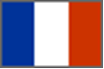

Finish

Colouring flags

Instructions: Cut and color the flags, then paste it on your notebook!

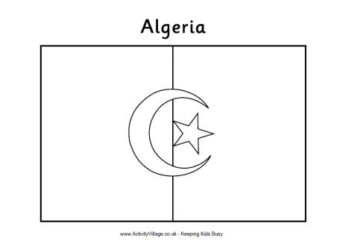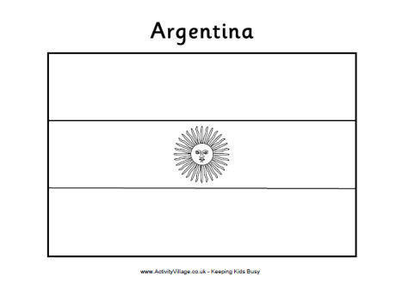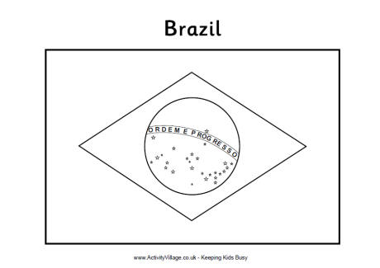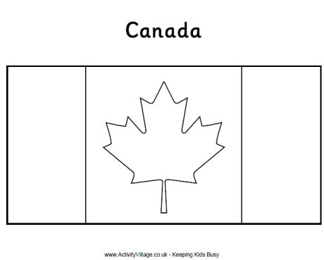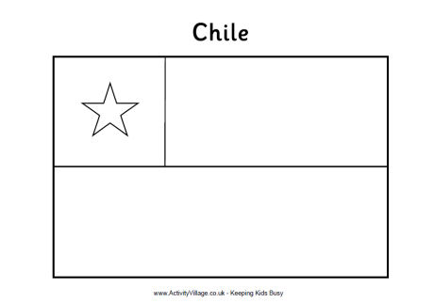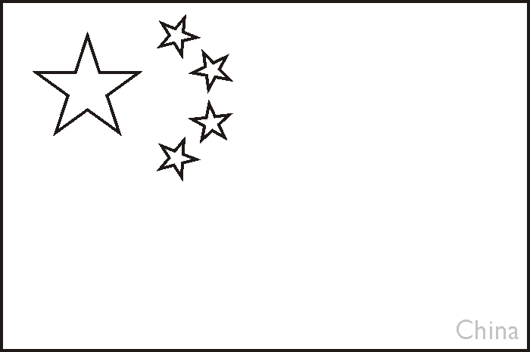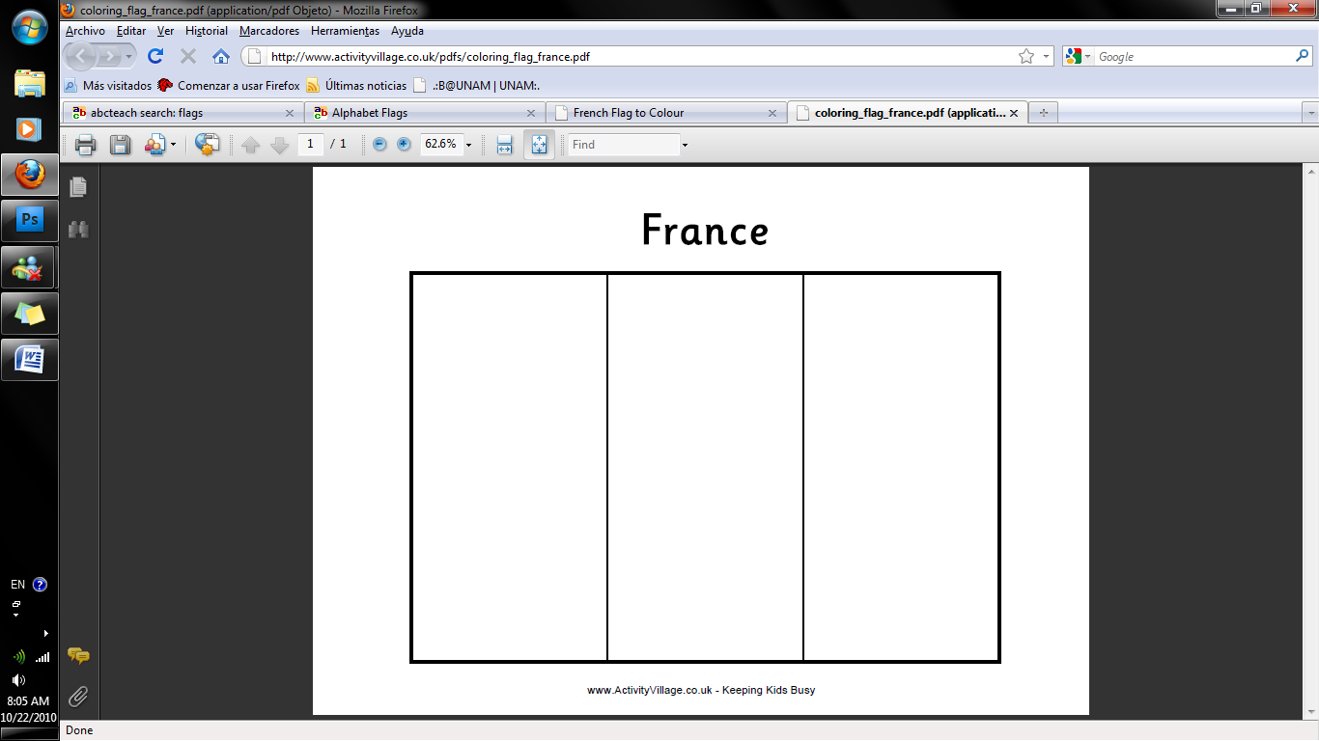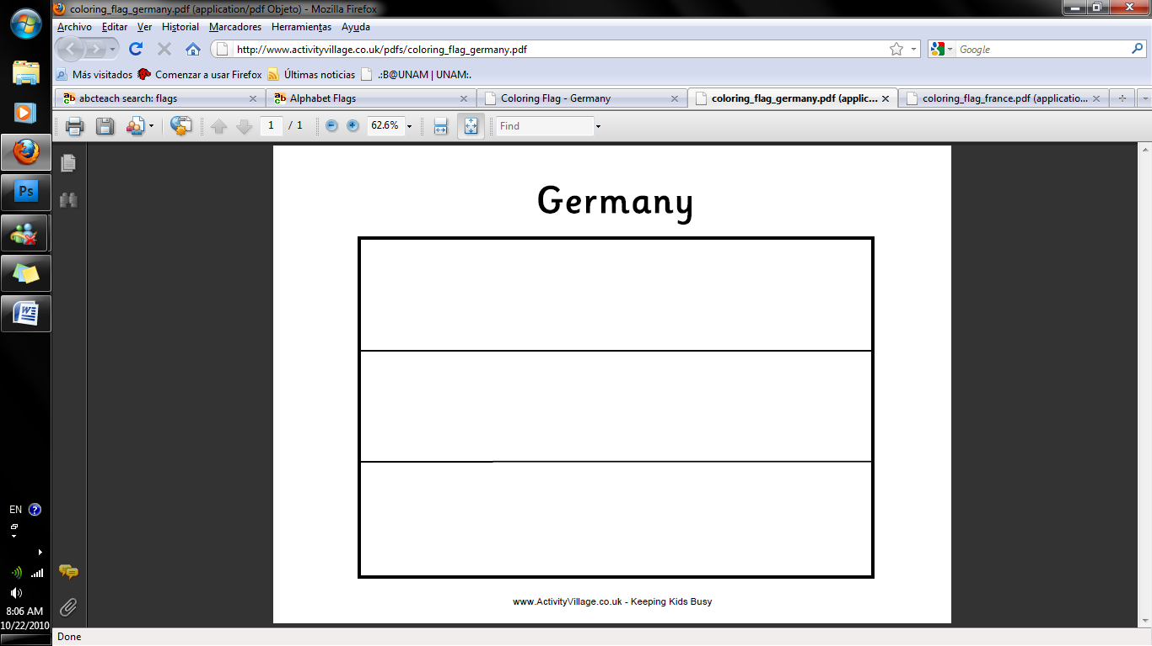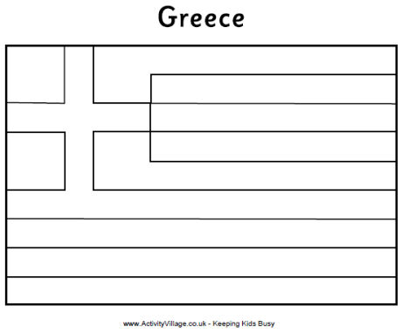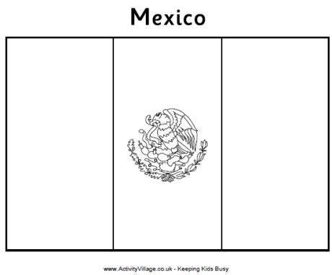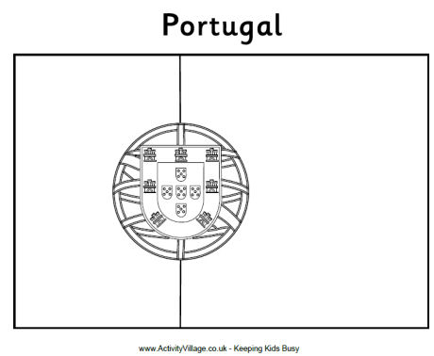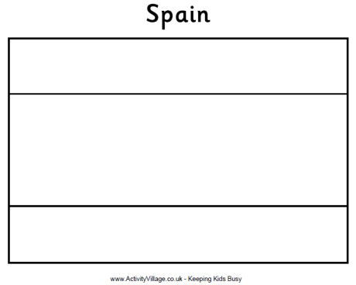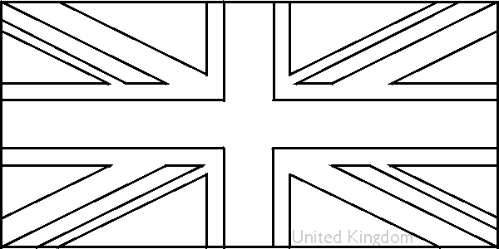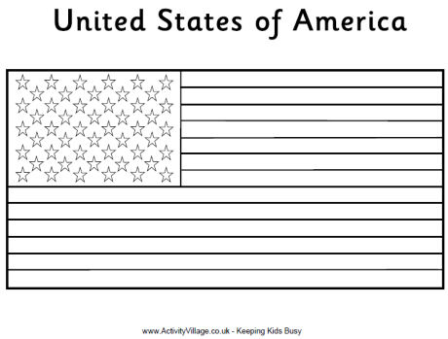

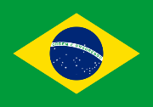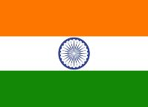

**3**

**1**

**5**

**Whose flag is it?**

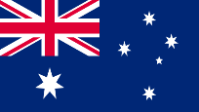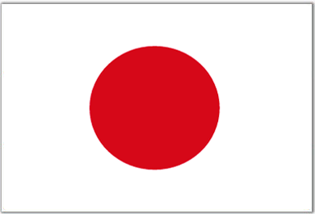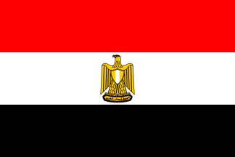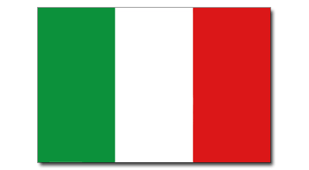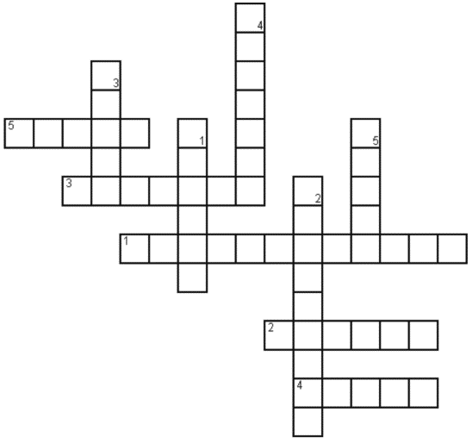

**Word Bank**

Brazil Australia

England United States

Italy Japan

Ireland India

Egypt Canada

**2**

**2**

**3**

**5**

**4d**

**1**

**4**

Siz istagan mavzuda sifatli qilib dars ishlanma tayyorlab beramiz.

**Narxi: 10 ming so’m**

To’lov klik yoki payme orqali

Buyurtma berish uchun bog’laning:

Telefon: +998911800985  
**Telegram:** +998911800985 yoki @hasanboy_uz  
**E-mail:** [xasan_92@mail.ru](mailto:xasan_92@mail.ru)