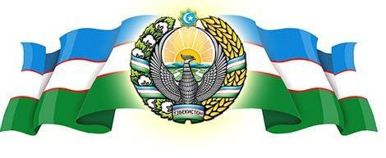 **______________ VILOYATI _________ TUMANI XALQ TA’LIMI BO’LIMIGA QARASHLI**

**___-SONLI O’RTA TA”LIM MAKTABI**

**INGLIZ TILI FANI O’QITUVCHISI**

***_______________________________NING***

8-sinflar uchun Unit 8. Lesson 4  
***Famous statues***

mavzusida 1 soatlik

**Dars ishlanmasi**

_______________ -2018

**Date_____ Form_____ Subject: English**

**Theme: Famous Statues**

**Aims:**

***Educational****:* - to talk about some famous statues in Uzbekistan, the USA and the UK; to practise talking about a statue they would like to have using ‘will’

***Developing:*** - to practise comparing statues using the superlative; to practise listening for detailed information; to practise writing a description of a statue (homework)

***Socio-cultural:*** - to learn about famous statues in Uzbekistan, the USA and the UK

***Up bringing****:* - to enrich pupils’ knowledge of our tradition and nation

***Learning outcomes for English competence C1, C2, C3, C4, C5, C6:*** At the end of the lesson pupils will be able to talk about famous statues in Uzbekistan, the USA and the UK

***Type of the lesson:*** Mixed, group work, pair-work, individual work

***Method of the lesson:*** nontraditional, mixed

***Equipment of the lesson:*** Textbook “Fly High 8”, pictures, internet, computers, projector

**TECHNOLOGICAL MAP OF THE LESSON:**

|  |  |  |  |
| --- | --- | --- | --- |
| **№** | **Part of the lesson** | **Tasks** | **Time** |
| 1 | Organizational  Moment | -to greet pupils.  - to check up the register | 5 min |
| 2 | Repeating last lesson | - to give pupils some questions about last lesson. – to ask words from previous lesson | 5 min |
| 3 | Explaining new theme | - to explain to pupils new vocabulary and theme | 20 min |
| 4 | Consolidating new theme. | - to consolidate new theme and new words of the theme. | 10 min |
| 5 | Marking. | - To mark pupils | 5 min |
| 6 | Homework. | - Giving homework. |

**Procedure of the lesson:**

***I. Organizing moment:*** Motivation,Greeting, checking attendance, season, weather, checking the preparation for the lesson.

***II. Asking homework:***

- Check for homework given on past lesson.

- Ask pupils all new words learnt on previous lesson.

***III. Pre-activity:***

**Activity 1 Work in groups. Look at the pictures. Ask and answer.**

**Objectives:** to stimulate PP ideas about the topic: to prepare for the next activity

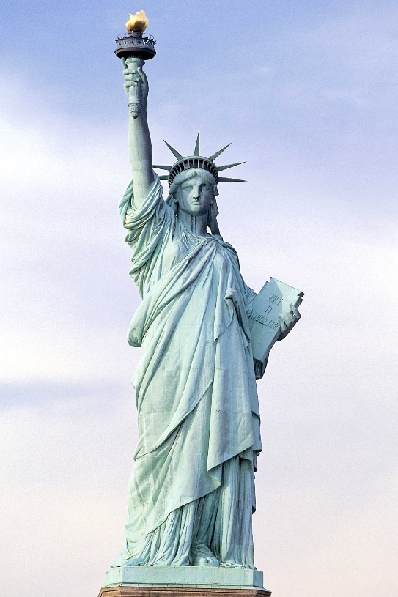PP look at the statues and answer the questions.

1 Have you ever seen these statues?

2 Do you know who made them?

3 Do you know where they are?

4 Do you know their names?

5 Do you like them? Why? /Why not?

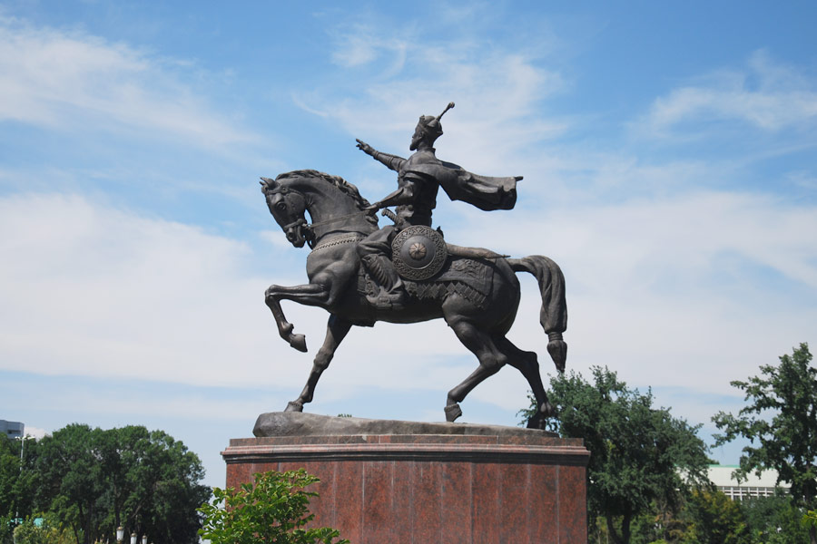

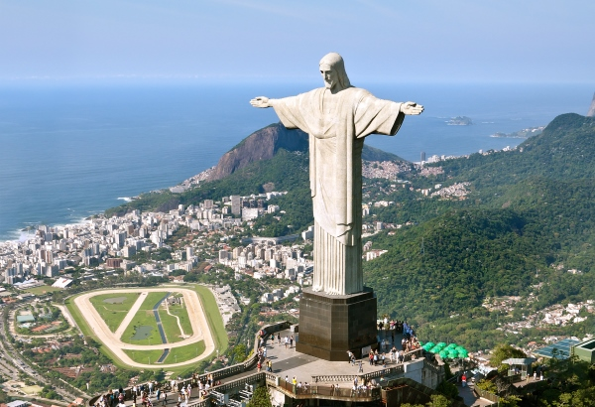

***IV. Main part***

**Activity 2a Copy the table. Listen to the guides talking about some famous statues and complete the information in the table for each statue.**

**Objective:** to practise listening for detail

PP listen to the CD and complete the table. Before listening, write the words

‘unveil, weapon, tablet, at the foot of' on the BB and explain their meaning.

|  |  |
| --- | --- |
| Sculptor: |  |
| Sculpture: |  |
| Date: |  |
| Location: |  |
| Words: |  |
| Metres: |  |
| Kilos: |  |
| Material: |  |

**CD script**

|  |
| --- |
| 1 Uzbek people don’t forget their ancestors. Sculptor llkhom Jabarov made the statue of the great statesman Amir Temur. It was unveiled in 1993 in the centre of Tashkent. It is made of bronze. It shows Amir Temur on his horse. He holds the horse with his left hand and his empty right arm stretches ahead. He has no weapon. He wishes peace and happiness to all peoples. His words “Strength is in justice” are written at the foot of the statue. It will always make our people feel proud.  2 The Statue of Liberty is the largest statue ever made. It stands 93 metres high and weighs 225 tons. It’s a steel female figure. The right arm holds a great torch and the left arm holds a tablet with the date of adoption of the Declaration of Independence, July 4th. The statue was designed by Frederic Bartholdi, a French sculptor and it was presented to the people of the United States by the people of France to remember their friendship on July 4,1884. The Statue of Liberty is a symbol of freedom to millions  around the world.  3 Nelson’s Column stands in the centre of Trafalgar Square in the very centre of London. The statue is of Admiral Viscount Horatio Nelson, a great British Naval hero. It was paid for by the people of Britain. The statue is made of stone and it stands on a bronze base at the top of a very high stone column. The column was designed by William Railton in 1842 and the statue by E. H. Bailey in 1843. The column is 172 feet high and the statue 18 feet high. That's approximately 58 m and 6 m. Admiral  Viscount Nelson lost an eye and his right arm in battles. If you look carefully you can see that he has a sword; pointing to the ground in his left hand and his right arm is in his jacket. The four famous lions which guard the foot of the column were added in 1868. They are made of bronze and were sculpted by Edward Landseer. |

**Activity 2b Work in groups of three. Ask and answer the questions.**

**Objectives:** to practise superlatives; to enable PP to talk about sculpture

PP work in groups. They ask and answer the questions. When PP are getting

near the end, bring the class together and discuss some of the answers with

the whole class.

1 Which statue is the biggest?

2 Which statue is the oldest7

3 Which statue is the most interesting7

4 Which words do you like best?

5 Are there any statues in your place or near your place?

6 If you were in charge of the art budget for your place

would you build statues?

**Activity 3a Work in groups. You are going to build a statue. Decide:**

**Objectives:** to give an opportunity to work creatively; to revise the Future Simple;

• who or what it will be

• where it will be

• what it will be made of

• what size it will be

• what the words will be

**3b Present your ideas to the class.**

**Objectives:** to give further practice in talking about sculpture

Ask PP to work in pairs or groups to dicsuss their ideas and come up with a plan. They should note down their ideas and be ready to present them to the class. When some groups have finished, stop the activity and ask groups to tell the class about their sculptures.

***V. Post-activity***

**Activity 4 Complete the sentences using the Active or the Passive Voice. You must either use Simple Present or Simple Past.**

**The Statue of Liberty**

1. The Statue of Liberty (give)……………….. to the United States by France.

2. It (be) …………… a present on the 100th anniversary of the United States.

3. The Statue of Liberty (design) ……………….. by Frederic Auguste Bartholdi.

4. It (complete)………………………….. in France in July 1884.

5. In 350 pieces, the statue ………… then (ship) ………………. to New York, where it (arrive) ……………………. on 17 June 1885.

6. The pieces (put)……………………… together and the opening ceremony (take)………………….. place on 28 October 1886.

7. The Statue of Liberty (be) ………………. 46 metres high (93 metres including the base).

8. The statue (represent) …………………… the goddess of liberty.

9. She (hold) …………………… a torch in her right hand and a tablet in her left hand.

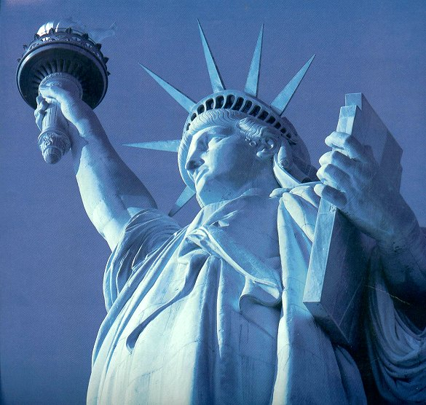10. On the tablet you can (see) ………………… the date of the Declaration of Independence: July 4, 1776.

11. During the restoration completed in 1986, the new torch ……… carefully (cover) …………………. with thin sheets of 24k gold.

12. Every year, the Statue of Liberty (visit)……………………… by thousands of people from all over the world.

**Activity 5 Let’s talk about superlatives**

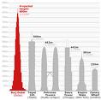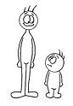Let’s talk about **SUPERLATIVES**

**Conversation cards**

What the biggest country in the world? Where is it? What are its neighbours?

What’s the highest mountain in the world? In Europe? In South America? In Africa?

What’s the most populous country in the world?

What’s the most populous Muslim country in the world?

What’s the longest river in the world? In Asia? In North and South America? In Europe?

What’s the biggest land animal? Where does it live? What does it eat?

What’s the biggest animal in the world? Where does it live? What does it eat?

What’s the biggest bird in the world? Where does it live? Describe it.

What’s the biggest ocean in the world? Where is it?

What’s the biggest fish?

What’s the fastest animal on land? Describe it.

Who’s the fastest in the sky?

What’s the biggest city in the world? What’s the biggest city in your country?

What’s the highest building in the world? What’s the highest one in your country?

What’s the largest desert in the world? Where is it?

What animals live there?

What’s the smallest country in the world?

Where is it?

Who’s the richest person on Earth? How much money does he have? Guess.

Which country is the most popular tourist destination in the world? Guess. Say why.

What’s the hardest substance on Earth?

What is it used for?

What’s the best-paid job?

What’s the worst-paid job?

Brainstorm and discuss.

What’s the biggest continent?

What’s the coldest?

What’s the driest?

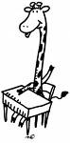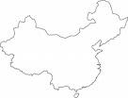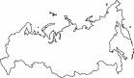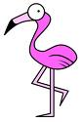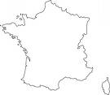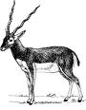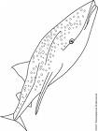

4

5

8

7

6

2

1

3

**Class survey**

|  |  |
| --- | --- |
| What's the best food you've ever eaten? |  |
| What's the best movie you've ever seen? |  |
| What's the most beautiful place in your country? |  |
| What's the most difficult school subject? |  |
| What's the most expensive present you've ever bought? |  |
| What's the most tourist attraction in your country? |  |
| What's the worst food ever? |  |
| Who's the best teacher you've ever had? |  |
| Who's the most beautiful woman on Earth? |  |
| Who's the most handsome man in the universe? |  |

**Match**

|  |  |
| --- | --- |
| antelope |  |
| China |  |
| flamingo |  |
| France |  |
| giraffe |  |
| rhino |  |
| Russia |  |
| whale shark |  |

|  |  |  |
| --- | --- | --- |
| Russia  (its neighbours are Azerbaijan, Belarus, China, Estonia, Finland, Georgia, Kazakhstan, Latvia, Lithuania, Mongolia, North Korea, Norway, Poland, and Ukraine | (1) China +/- 1.3 billion  (2) India +/- 1.1 billion  most Muslims:   1. Indonesia (200 million) 2. India (138 million) | Mt. Everest (Nepal)  Mont Blanc (France)  Aconcagua (Argentina)  Mt. Kilimanjaro (Tanzania) |
| The Nile (Africa)  Yangtze River (China)  Mississippi (North America)  Amazon (South America)  Volga (Russia/Europe) | blue whale  (lives in the ocean)  (eats krill) | African elephant |
| ostrich (originally from Africa, now widely farmed all around the world) | cheetah (Africa)  (yellow-brown with black spots)  peregrine falcon | Pacific Ocean  (between Asia and America)  whale shark |
| Tokyo  (metropolitan area) | Sahara, Africa  (snake, reptiles, insects, scorpion, desert fox, camel) | Burj Dubai (601 metres) |
| Vatican City  (within the boundaries of Rome, Italy) | 1 - France (81.9 million tourist arrivals in 2007)  2 – Spain (59.2 million) | (Forbes - March 2009)  1. Bill Gates (USD 40 billion)  2. Warren Buffet (USD 37 billion) |
| diamond  (used for jewellery, industrial cutting and engraving tools, laser components, semiconductor coatings) | biggest: Asia  coldest: Antarctica  driest: (1) Antarctica (2) Australia | possible answers: doctor, surgeon, lawyer, celebrity, businessman, pilot, football player, film star  possible answers: maid, janitor, cleaner, teacher, construction worker, farmer, care worker, nurse |

**Answer key:**

***VI. Evaluation.*** Giving marks

***VII. Homework***

Write about any statue you know and talk about it. (If you do not know one, find a picture of one in your school library.) Begin like this:

The statue of Amir Temur stands in a small park ... It was first shown in ...

1 Where is it?

2 Who is the sculptor?

3 What is it made of?

4 When was it first shown?

5 Why was it made?

6 What do you feel?

Siz istagan mavzuda sifatli qilib dars ishlanma tayyorlab beramiz.

**Narxi: 10 ming so’m**

To’lov klik yoki payme orqali

Buyurtma berish uchun bog’laning:

Telefon: +998911800985  
**Telegram:** +998911800985 yoki @hasanboy_uz  
**E-mail:** [xasan_92@mail.ru](mailto:xasan_92@mail.ru)