 **______________ VILOYATI _________ TUMANI XALQ TA’LIMI BO’LIMIGA QARASHLI**

**___-SONLI O’RTA TA”LIM MAKTABI**

**INGLIZ TILI FANI O’QITUVCHISI**

***_______________________________NING***

9-sinflar uchun Unit 8. Lesson 2  
***At the haidresser***

mavzusida 1 soatlik

**Dars ishlanmasi**

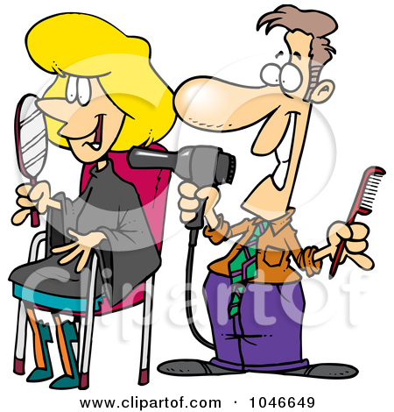

_______________ -2018

**Date_____ Form_____ Subject: English**

**Theme: At the hairdresser**

**Aims:**

***Educational****:* - to enable PP to talk about running a small business; to enable PP to tell the hairdresser how they would like their hair; to revise and practise asking for the spelling of words

***Developing:*** - to practise reading for detailed information; to raise awareness of issues in running a small business (homework)

***Socio-cultural:*** - to revise and practise greetings and responding to greetings on the

Telephone;

***Up bringing****:* - to enrich pupils’ knowledge of our tradition and nation

***Learning outcomes for English competence C1, C2, C3, C4, C5, C6:*** At the end of the lesson pupils will be able to talk about running a small business; to tell the hairdresser how they would like their hair

***Type of the lesson:*** Mixed, group work, pair-work, individual work

***Method of the lesson:*** nontraditional, mixed

***Equipment of the lesson:*** Textbook “Fly High 9”, pictures, internet, computers, projector

**TECHNOLOGICAL MAP OF THE LESSON:**

|  |  |  |  |
| --- | --- | --- | --- |
| **№** | **Part of the lesson** | **Tasks** | **Time** |
| 1 | Organizational  Moment | -to greet pupils.  - to check up the register | 5 min |
| 2 | Repeating last lesson | - to give pupils some questions about last lesson. – to ask words from previous lesson | 5 min |
| 3 | Explaining new theme | - to explain to pupils new vocabulary and theme | 20 min |
| 4 | Consolidating new theme. | - to consolidate new theme and new words of the theme. | 10 min |
| 5 | Marking. | - To mark pupils | 5 min |
| 6 | Homework. | - Giving homework. |

**Procedure of the lesson:**

***I. Organizing moment:*** Motivation,Greeting, checking attendance, season, weather, checking the preparation for the lesson.

***II. Asking homework:***

- Check for homework given on past lesson.

- Ask pupils all new words learnt on previous lesson.

**

***III. Pre-activity:***

***Activity 1a* Look at the picture and answer.**

**Objective:** to establish the context and prepare for

reading and listening

PP look at the picture and answer the question.

Key: 1 At the hairdresser. 2 She is having her hair cut.

*1 Where is it?*

*2 What is the girl having done?*

***IV. Main part***

***Activity 1b* Listen to the conversation and write when the appointment is.**

**Objective:** to listen for detail

Ask PP to copy the Appointments book page into their Ex.Bks. if they have not already done so. Ask PP to listen to the conversation and complete the page in the Appointments book.

**CD script**

**Receptionist:** Good morning. Legends hairdressers. How can I help you?

**Lucy:** Good morning. I’d like to make an appointment to have my hair cut.

**Receptionist:** OK. When do you want to come? I’m afraid next week is completely booked. I can fit you in on Monday 12th March at 10.00 in the morning.

**Lucy:** Monday is OK, but not in the morning I’m afraid. Could I come in the afternoon?

**Receptionist:** Yes, OK. What about 3 o’clock?

**Lucy:** Yes, that’s fine.

**Receptionist:** Could I have your name, please?

**Lucy:** Yes, my name’s Whitfield.

**Receptionist:** Could you spell that for me, please?

**Lucy:** W-H-I-T-F-I-E-L-D.

**Receptionist:** Thank you. So, Monday 12th at 3 o’clock.

**Lucy:** Yes. Thanks very much. Goodbye.

**Receptionist:** Thank you. Goodbye.

***Activity 1c* Work in pairs. Pupil A use this page. Pupil B use page 84.**

**Objective:** to revise and practise making telephone calls

This is a normal information gap activity. PP work in pairs and do the activity. When they finish they can compare their Appointment books.

**

**Pupil A use this page**.

**Pupil B use page 84.**You are the hairdresser. Expect a phone

call from a customer.

Pupil B: telephone the hairdresser and make an appointment.

Name: John Ducane

You want: hair/cut on Tuesday

You can’t come in the afternoon.

***Activity 2a* Find in the Wordlist and translate.**

**Objectives:** to prepare for the next activity; to practise working with the Wordlist

PP find the words in the Wordlist and translate them (or, if you prefer, you can simply tell PP). Then practise the pronunciation of the words with PP. PP say

the words after you in chorus/rows and individually.

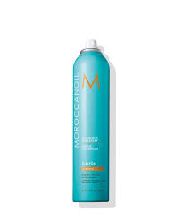  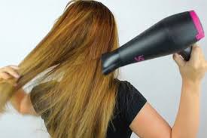 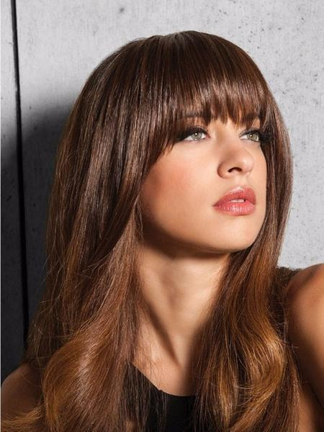

parting colour chart hairspray perm blow dry a fringe

**Language Note**

Perm is short for ‘permanent wave’ and is the normal term used.

***Activity 2b.* Read the text about Lydia and answer the questions**Objective : to practise reading for detail and general information

Lydia is a Hairdresser



This is Lydia. She is nineteen. She is tall and slim. She has curly brown hair and blue eyes. She lives with her parents.

Lydia is a hairdresser. She loves her job! She always gets up at 7.30 and she has a shower. After that, she has a cup of coffee and a piece of toast. She usually gets the bus to work, but sometimes her Mum gives her a lift. She cuts hair and styles it. Ladies are always happy with their hairdo: they never complain! Lydia wants to buy her own salon and so she saves her money.

She has lunch at one o’clock, usually just a sandwich. She leaves work at six and gets home half an hour later. Her Mum always cooks dinner. In the evening, Lydia watches TV and goes to bed at about eleven o’clock. She never stays up late!

She goes out on Saturday nights with her friends. They go into town. They usually have a pizza and often they go to a bar afterwards. Lydia hasn’t got a boyfriend at the moment. But she really fancies someone! His name is Mark. He is twenty one and very handsome! He works in the garage opposite the hairdresser’s. Lydia sees him every day. They always smile at each other. She hopes that very soon, he will ask her out. Let’s wish Lydia the best of luck with Mark!

1. How old is Lydia?

2. Who does she live with?

3. Is she short?

4. What colour is her hair?

5. What colour are her eyes?

6. What is her job?

7. Does she hate her job?

8. What time does she get up every day?

9. What does she have for breakfast?

10. Does she always get the bus to work?

11. Who sometimes gives her a lift to work?

12. Are Lydia’s customers always happy?

13. Does Lydia spend all her money?

14. What time does she have lunch?

15. What does she usually have for lunch?

16. What time does she get home?

17. Does Lydia cook the evening meal?

18. Does she sometimes stay up late?

19. What does she do on Saturday nights?

20. Who does Lydia fancy and how old is he?

21. How often do they see each other?

22. Do Lydia and Mark always smile at each other?

***Activity 2c* Read and say what Lucy would like to do with her hair.**

**Objective:** to revise the material of Lesson 1 and to practise reading for detail

Ask PP to read the conversation and say what Lucy would like to have done with her hair.

**Hairdresser:** Hello. Please come and sit down. Now, what would you like to have

done?

**Lucy:** Hello. I ’d like to have my hair cut and coloured.

**Hairdresser:** H ow do you want it cut - medium, short?

**Lucy:** No, not too short. I want to have my ears covered. And I like my fringe long.

**Hairdresser:** H ow do you usually have your hair? Do you have a parting?

**Lucy:** Yes, I have a parting about here on the right.

**Hairdresser:** OK, so not too short and what about the colour? Here’s a colour chart.

**Lucy:** I want to have my hair coloured black.

**Hairdresser:** OK, let’s get started. (two hours later)

**Hairdresser:** OK. Any hairspray?

**Lucy:** No, no hairspray, thanks.

**Hairdresser:** OK. That’s it. I hope you like it.

**Lucy:** Yes, it’s great. It’s just what I wanted. It makes me feel beautiful!

**Hairdresser:** Good – and you are beautiful!

***Suggestion:*** If you think your PP may have forgotten the construction ‘it makes

me feel’ + adj., you could do Grammar Exercise 1 here, or assign it for

homework, if you think your PP need to do it.

***Activity 3* Role play. Work in pairs. Take turns to be the hairdresser. Look at the price list and choose what you want to have done.**

**Objective:** to practise conversations at the hairdresser’s

Divide PP into pairs (hairdresser and customer). Ask them to role play using the conversation in 2d as an example and using the price list to give support with vocabulary. They can take turns to be the hairdresser. While PP are role playing, go round and monitor. Help out where necessary and make a note of any common mistakes. When most PP have finished, let a few pairs perform their conversations for the class. Then tell PP about any mistakes you noticed and ask them to correct the mistakes.



***V. Post-activity***

***Activity 4* Compare the prices of the different services. Use the phrases in the cloud.**

**Objective:** to practise talking about prices using the comparative

PP make sentences using the phrases in the cloud.

cheaper than more expensive than greater than less than

1 The cost of a perm / a wash and blow dry.

2 The price of a hair cut for men / the price of a hair cut for women.

3 The cost of a wash / the cost of a hair cut.

4 A new style / a blow dry.

***VI. Evaluation.*** Giving marks

***VII. Homework***

1 Leave time to explain the homework to PP. The first part is a bit different from the kind of things PP usually do. This time they are going to think about running a small business. They have to look at the appointments for the day in Activity 3, work out how much money the hairdresser will make, then work out the costs for the day, take the costs away from the money the hairdresser will make and so work out the profit.

**Activity I**. **1 Read and find how much the hairdresser will earn for the day.**

**2 Read and say what the hairdresser’s costs for a day are.**

**3 Answer the questions:**

1 Does the hairdresser make a profit?

2 If so, how much?

3 Can she make more profit? How?

**Key:** total earnings are 210, costs are 80, so profit is 130. The hairdresser can make more money by working longer in the afternoon.

2 PP write five sentences for Activity 2b to practise the new structure.

**II.** **Write five sentences for Activity 2b.**

***Deputy director on educational affairs ___________ Signature _________***

***Conversation cards. At the hairdresser’s***

|  |  |
| --- | --- |
| **Hairdresser:**  What can I do for you?  Would you like just a trim or a new hairstyle?  How would you like me to cut it?  How short would you like it?  Have you got a parting?  What colour would you like?  Would you like anything on it? | **Customer:**  I would like ….   * just a small trim * a new colour   I don’t want my hair too short.  How much is that? |
| **Hairdresser:**  What can I do for you?  Would you like just a trim or a new hairstyle?  How would you like me to cut it?  How short would you like it?  Have you got a parting?  What colour would you like?  Would you like anything on it? | **Customer:**  I would like ….   * just a small trim * a new colour   I don’t want my hair too short.  How much is that? |
| **Hairdresser:**  What can I do for you?  Would you like just a trim or a new hairstyle?  How would you like me to cut it?  How short would you like it?  Have you got a parting?  What colour would you like?  Would you like anything on it? | **Customer:**  I would like ….   * a new hairstyle * some highlights ( blond)   I don’t want my hair too short.  I want a French plait.  How much is that? |
| **Hairdresser:**  What can I do for you?  Would you like just a trim or a new hairstyle?  How would you like me to cut it?  How short would you like it?  Have you got a parting?  What colour would you like?  Would you like anything on it? | **Customer:**  I would like ….   * a new hairstyle * a colour (only the roots) * a fringe   I would like my hair short.  How much is that? |
| **Hairdresser:**  What can I do for you?  Would you like just a trim or a new hairstyle?  How would you like me to cut it?  How short would you like it?  Have you got a parting?  What colour would you like?  Would you like anything on it? | **Customer:**  I would like ….   * just a small trim * some lowlights (brown) * a side parting   I don’t want my hair too short.  How much is that? |
| **Hairdresser:**  What can I do for you?  Would you like just a trim or a new hairstyle?  How would you like me to cut it?  How short would you like it?  Have you got a parting?  What colour would you like?  Would you like anything on it? | **Customer:**  I would like ….   * a small trim * a fringe * a centre parting * a new colour (red)   I want my hair short.  How much is that? |

Siz istagan mavzuda sifatli qilib dars ishlanma tayyorlab beramiz.

**Narxi: 10 ming so’m**

To’lov klik yoki payme orqali

Buyurtma berish uchun bog’laning:

Telefon: +998911800985  
**Telegram:** +998911800985 yoki @hasanboy_uz  
**E-mail:** [xasan_92@mail.ru](mailto:xasan_92@mail.ru)