“The purpose of life is to live and teach it to taste experience to the utmost to reach out eagerly and without fear for newer and richer experince “E.R

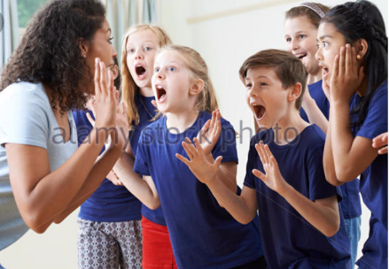

District :Sergeli
Done by : Haitova Barno

Toshkent 2018

Theme : How to inspire and motivate pupils ?
“ The Best teachers are those who think carefully about what they are going to do in their classes and who plan how they to organise the teaching and learning”

“My quizzes “ are performed by the pupils of the 5th class

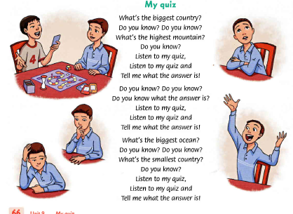

Stage Performance is performed by the pupils of the 7th grade
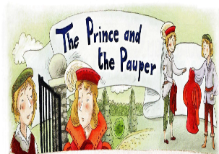Drama lesson is performed by 6th grade
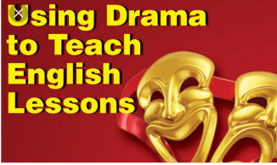

Script of Scenario for a month of foreign Languages
Speaker : Greeting: Good morning dear teachers and guests! We are glad to see you at our festival . It is called “How to inspire and motivate during the lesson?
Speaker : You are welcome ! The President of our country has created a number of conveniences and innovations for the teachers .This is a constant challenge for us to constantly improve our knowledge and experience because today is difficult to increase pupils interest in 21st technology age century However it is an indication of a greater deal of effort .
Speaker : In order to that today’s teacher is the achievement of high competence in teaching his own pedagogical image .
Speaker : Now ,lets get it to the district methodeologist to open the event .
Methodeologist : Thanks a lot .Good morning to teachers and guests! Today our experience trainers help our pupils learn how to inspire and motivate pupils Personally I think that bright pupils can be strong foundation for the vivid future. So we can achieve the goal of exchanging experiences with our experienced trainers.
Now we all want to see the lessons .We forget to introduce you as we do , today we are accompanied by travelling companion . They are “Bilag’on “ and “Bilmasvoy “ .
Speaker: Really happy from it .We have selected four ways to attract and inspire pupils with request of the trainer .
Speaker : Now in the 5th class. “MY Quiz” are performed by the pupils of the 5th class . Listen one of the most effective ways to use different songs for interest in learning English language .
Lyrics of song!
“My Quiz”
What’s the biggest country .
Do you know ? Do you know?
What’s the highest mountain ?
Do you know?
Listen to my quiz .
Listen to my quiz and ,tell me What’s the answer is ?
What’s the biggest ocean ?
Do you know? Do you know ?
Do you know what’s the answer is ?
Listen to my quiz and tell me what the answer is ?
What’s biggest ocean ?
Do you know? Do you know?
What’s the smallest country ?
Do you know ?
Listen to my quiz ,
Listen to my quiz and Tell me what the answer is?
Bilmasvoy: I’m so inspired and excited from it . I don’t know why ,my teacher didn’t use songs during the lesson . I have taken lyrics of the song from trainer. And I’m going to sing a song with my friends.
Speaker : You are right ,We have also another one , the experienced tutor and students will show another way to inspire the study of English while watching a drama lesson .
Bilag’on : However , My brother “Bilmasvoy” doesn’t interested in learning the English language . I’m so astonished from it .
Speaker : Let’s go to drama lesson .
In the drama lesson trainer teaches children how to act in .
Trainer: Tell the story of a beautiful forest with friendly proud trees ,pretty flowers ,lively birds and a group of wonderful musicians . They all lived happily and peacefully until one day the mean giants were so big they were even bigger than the trees . They were so used to everybody being scared of them and they believed they can do whatever they want without thinking of the damage they are doing . The flowers and the trees had to bend and duck to stay out of their way and when they heard the beautiful music they were quiet for a bit and seemed to listen to the beautiful music , but it wasn’t too long before they grabbed the instruments from the musicians and started playing . Because they didn’t know how to play it sounded awful.
Everyone in the forest held their breath as they musicians and started playing . Because they didn’t know what will happen now, but the strongest thing happened …The giants got very sad and started crying ………….
Before we work on an ending to the story we are going to create some of the characters: Divide three groups. Represent all characters .
Trees : How do they move ? What sound or sounds do they make ? Each tree must be different –think of a tired tree , old one ,baby tree etc. pupils show happy trees and then scared trees . Depending on the time , trainer add more emotions to this section.
Flowers :How do the move dear pupils ? what sounds do they make ? Each flower must be different – think of a tired flower , old one ,baby flower ,small flower , big flower etc. Pupils show happy flowers and then show scared flowers.
Birds : How do they move ? what sounds do they make ? Each bird must be different –think of a tired bird old one ,baby bird, small or big bird etc .Pupils show happy birds and then show scared birds.
Musicians: What instrument do they play ? How do they play it ? Sound It makes
Giants : How do they move ? Their language ? Make them different –old ,young, slow, quick, etc. Pupils show angry giants and sad giants .
Trainer: This activity can be used very successful with special needs pupils and also kinaesthetic learners and auditory learners . .If you have physically disabled pupils ,you can adapt the movements so those who can’t move can use facial expressions to show their emotions .
Bilmasvoy : After I watched drama lessons then I’m interested in studying English well. Because I don’t want to learn English well enough to let the 6th grade pupils enjoy a fascinating fairy tale with a stunning figure .
Speaker .Actually you are right !
Musical Pause : “ Come and play with me !
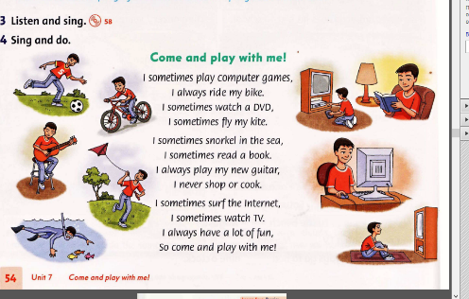

Speaker : Third way is stage performance by the 7th grade pupils .Lets watch and have a rest . Stage Performance : The Prince and The Pauper .
Narrator : Tom Canty was a boy from a very poor family .His clothes were old and dirty and he never had enough food. Tom believed that he could have a better life one day, he was clever and he knew how to read to write ,he wanted to get a good job and earn money to have a house , clothes and good food. One day , Tom was outside the palace gates when he saw Prince Edward Tom stood and watched the Prince for a while .The Guards tried to send Tom away ,but the Prince stopped them .The two boys were very surprised when they saw each other .
Tom : I want to be like you said to Edward you are rich and you can have everything you want.
Edward: I want to be like you ,you are free you can do everything you want .
Narrator : They just like a twins .
Edward : I didn’t really like life outside the palace .I saw that life was very difficult for poor people ,I decided to be a good king and help the people of England .
Tom: I was pretending to be Prince .It wasn’t easy .I didn’t know how to act or what to say to people .
Narrator : But Tom was a clever boy and he learned quickly .He had lots of good ideas and he was good and making important decisions .But Edward &Tom tried to tell people truth .
Tom: I’m not a Prince .
Edward : I’m the real Prince Edward. We are sorry we liked .It was only a game .
Narrator : But nobody can believe to them . At that time the showed wax disc was the Great Seal of England . Only the true King England has the Great Seal . So Edward became King , but he remembered hiss adventures he learned when he was with Miles . He was a good King and he helped the people of England .He made sure that life was bitter for poor people and Tom became a very important man .He was never poor or hungry again . At the end of our stage performance I think that you never stop to learning and dreaming because one day will come your dreams come true. Tom is poor boy but he has got good knowledge . So his fate had happy end !
Methodeologist : Starting with a respectable kind and hard working teacher your fellowman has been interested in studying the English ,which shows that your experienced professionals in your area are instructed by their skilled masters.
Speaker: We invite you to take part in discussion and to share you feedback on each event you have taken .
Speaker :Today we are grateful to our teachers who have made a great contribution to this event in their interesting and meaningful way . During the event ,it is important to find pupils interested in classroom learning ,the highest responsibility on each teachers shoulders. We know highest score given to the teacher is in the accomplishments of the trainees. I wish you live in Luck forever!
Bilmasvoy and Bilag’on: We don’t know for sure today that we took an active part in taking part in the event and in the future we’ll learn the perfect English language. We are glad to congratulate your teachers on the occasion of your success.
Rewarding Time : giving praiseworthy to trainers, pupils and teachers by District methodeologist .
Speaker : Good bye dear hardworking teachers and learners!
“The highest result of education is tolerance “ J Harmer
Thanks a lot who has created chance to us !

