Shahrixon tumani 61-maktabda May-Ingliz tili fan oyligida
6-sinflar o’rtasida “LET’S LEARN SOMETHING” nomli o’tkaziladigan tadbir senariysi.

Stage will be decorated using some English pictures, flowers and balloons. Three teams compete each other in the competition. There are 5 tasks :
- Introduction(three groups introduce themselves with their presentation)
- Get in line (groups must stand in the correct line and make sentences)
- Quiz (each group should answer to five questions)
- Do spelling ( members of groups must do correct spelling words which is said by judges)
- Independent theme. (groups can show something which they want in English)

Narrator 1: Good morning dear teachers and clever pupils. Today we are gathering here to watch competition among the three groups: forms 6a,6b and 6v and of course to learn something. Samandar what do you notice names of groups? (The USA group is 6a, The UK is 6b and Australia is 6v)
Narrator2: Yes it is very interesting, I think they are the names of English speaking countries. These groups will exam their English knowledge by five tasks. Every group has 8 pupils. The first task is an introduction and on this task they will introduce their groups. The first group is The USA and they will give us some information about the USA. The second group is the UK and they will tell some interesting facts about the UK. The third group is Australia and they will introduce us lots of information.
Narrator 1: Ok! Now lets call the groups to the stage and let’s introduce our judges:
1.Qochqarova Feruza opa(our librarian)
2.Akbarov Muzaffar and Tursunova Iroda (English teachers )
Narrator 2: Now groups can do task 1 turn by turn. Let’s check which group begin first and ok come on the leaders of groups and choose one of them (wait) ok group _________ will begin first. Others get ready!
Groups will begin the introduction with their presentations.
Narrator 2 : The second task is called “GET IN LINE”. On this task the groups must stand in line using the words in the correct order. Come again the leaders and choose an envelope.

The leaders will choose one and get in line with other members of the group
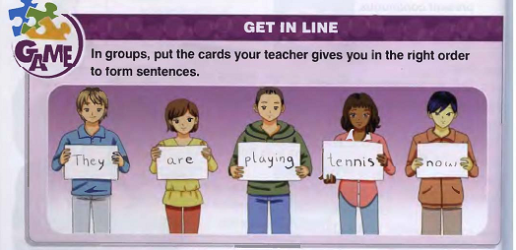.
Narrator 1: today the best pupils of our school, form 7a prepare something to show. Before beginning the third task let’s watch it.
The girls dance to the song (Pitbull&Jennifer Lopes-Dance)
Narrator 2: very beautiful! Ok now let’s begin the third task and on this task the groups will answer the five questions. Ok leaders come on here and choose one of them. And get ready! Good luck!
Questions for group 6a
- How many parts is the UK divided into?
- What is the population of Australia?
- What is the capital of the UK?
- What is the area of Australia?
- What is the climate like in the UK and Australia?
Questions for group 6b
- What is the population of the USA?
- How many metres is the Australian Alps?
- What is the nationality of the USA?
- What is the capital of Australia?
- What is the area of the USA?
Questions for group 6v
- What is the capital of the USA?
- How many metres high is the Rocky Mountains?
- Where is London situated?
- What is the capital of England?
- What is the nationality of the UK?

Narrator 1: now watch again from 7a.

And on this time boys dance to the song.( Michael Jackson-Don't care about us)
Narrator2 Great! On the fourth task one member of the groups will do spelling. Are you ready? Ok let’s begin listen carefully our teacher and do correct spelling.
Words to spell:
Tundra, climate, average, million, recycle, temperature, reduce, waste, the Aral sea, Scotland, sailing, sweep, dust, accident, route, continent, capital, population, Wales, koala, kangaroo, area, square, penguin, boat, helicopter, canteen, comfortable, fast food, fashionable, knife, comfortable, accept, refuse, cheap, expensive, pancake, ingredients, squeeze, special, attractive, wheat, recipe, race etc.

Narrator 1: And last task is independent theme which they want to show, but only in English let’s watch them turn by turn.
The groups show their independent themes.
Narrator 2: lets listen to the judges and know who is the winner group.
The judge will say the result of this competition.
Narrator 1: that’s end all of us know the winner. I think the other groups should be happy because they are able to tell something and of course learn a lot in English.
Narrator 2: of course you are right Samandar I hope the pupils, who watched the performance, learnt something. Good luck all of you! Thanks for your attention! Good bye.

