Picture test 2nd grade (10+5)
- I never go to school on ……. .
- B) C) D)
- My mum is a doctor. She works at ……. .
- B) C) D)
- ….. is the coldest season of the year .
- B) C) 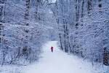 D) 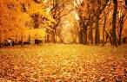
- Would you like …… of coffee ?
- B) C) D)
- What holiday we don’t celebrate in Uzbekistan ?
- B) C) D)
- At Navruz we eat delicious meal …… .
- B) C) D)
- I like 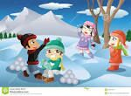 in winter.
- Play snowballs B) play hockey
- C) take photos D) make a snow man
- Every time I have ……… my mum takes my to the ……..
- B) C) 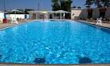 D)

- I always go to school on ……….
- 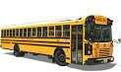 B)
C) D)
- ….. is the biggest city I Great Britain.
- B)
C) D)
- What city in the capital of Uzbekistan.
- Where can we buy books ?
- What’s wrong ? . I …… a high temperature.
- I have a ……. . I can’t speak .
- How ….. are these apples . They are two thousand sounds a …... .

Answers
Question | 1 | 2 | 3 | 4 | 5 | 6 | 7 | 8 | 9 | 10
Answer | C | B | C | D | A | C | A | B | D | A

11. Tashkent
12. At the bookshop
13. Have
14. sore throat
15. much / a kilo

