Хоразм вилояти Богот туманидаги
8 – сон умумий урта таълим мактабининг
Инглиз тили фани укитувчиси
Ниёзметова Зебо Зафарбековнаниг
4 – синфлар учун
инглиз тили фанидан RASMLI тестлари
1. Find the German flag?
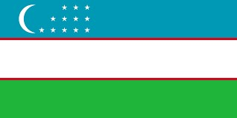
a) b) c) d)

- Find the o’clock? It is ten o’clock.
a) b) c) d)

- A glass of ________
- A cup of ________
- A bowl of ________
- A box of _________
a) Water b) salad c) tea d) chocolate

- ………… works in the garden.
a) Teacher b) pilot c) gardener d) cooker
- What’s the weather look like in winter

a) Hot b) cold c) rainy d) windy
- What is the fifth day of the week?
  - Friday b) Monday c) Saturday d) Thursday
- We live in Uzbekistan. We speak……….
  - French b) Uzbek c) English d) Turkmen
- Find the odd word?
  - February b) Monday c) November d) March

- She likes to help sick people.

a) Cook b) Doctor c) Mother d) Neighbor

13. What time is it?
- 14It is three o’clock

- It is twelve thirty

- It is ten fifty

- It is twelve o’clock

14. Find the types of transport which is move on the road?
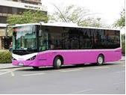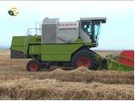

a) Bus b) excavator c) combine
15. Choose the correct answer.
- The winter in Uzbekistan is in December, January and February.
- The weather is always warm in winter.
- It is usually cold in winter.
- Sometimes the rain pours in December.

Questions | 1 | 2 | 3 | 4 | 5 | 6 | 7 | 8 | 9
Answers | c | a | a | c | b | d | C | b | a

10 | 11 | 12 | 13 | 14 | 15
B | b | b | a | a | b

