TEST for 5th grade
1….. is my favourite subject.
a)Mother tongue b) Literature c) English d)PI
2. The first lesson is English, ….. is mother tongue.
a)the third b) the second c) the fourth d) the fifth
3. What time is it?
a)It’s 6 o’clock b) It’s quarter past 7. c)It’s quarter past 6. d)It’s 5 o’clock
4.Children in …. go to school every day from Monday to Friday.
a)England b)Uzbekistan c) Germany d) Britain
5. My sister’s hair is ….
a)curly b)straight c)long d)dark
6.We never go to school on ……. .
a) b) c) d)

7. I sometimes go to school on ……….
a) b) c) 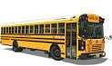d) 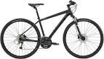
8. Children mustn’t 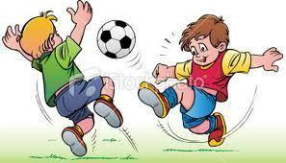in the classroom.
a) play basketball b) play badminton c) play tennis d) play football
9. I like winter because it is …. In winter.
a) 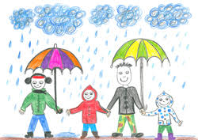 b) c) d)
10.My sister is a in the hospital.
a) pilot b)nurse c)teacher d)director
11. Describe this robot. This robot has a _ _ _ _ _ _ head. He has a _ _ _ _ _ body and _ _ _ _ arms and _ _ _ _ _ legs.
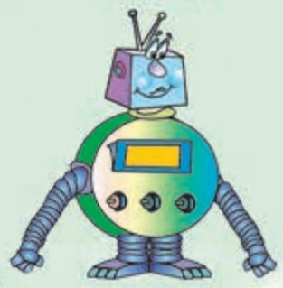

12.Who is he?
13.They went to the theatre .
14.My mother cooked on my birthday.
15.I like .
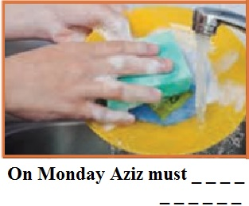
16. Complete the gap.

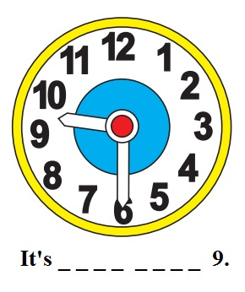
17. Tell the time.

18. My father bought a new 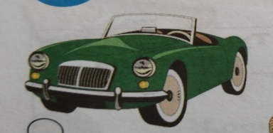 yesterday.
19. Would you like of tea ?
20. works in the canteen.

Answers:
1.a 2.b 3.a 4.c 5.a 6.c 7.b 8.d 9.d 10.b
11.square, round, long, short.
12.policeman
13.by bus
14. a birthday cake
15.sewing
16.wash the dishes
17.half past nine.
18.car
19.a cup
20.cook

